# AI-POWERED AUTOFILL PATIENT DISCHARGE SYSTEM

#### A SOCIALLY RELEVANT MINI PROJECT REPORT

***Submitted by***

### VINDHYA S [211423104739]

**YAMINI P [211423104748]**

***in partial fulfillment for the award of the degree of***

### BACHELOR OF ENGINEERING

**in**

#### COMPUTER SCIENCE AND ENGINEERING



**PANIMALAR ENGINEERING COLLEGE**

**(An Autonomous Institution, Affiliated to Anna University, Chennai)**

**OCTOBER 2025**

# BONAFIDE CERTIFICATE

Certified that this project report **“AI-POWERED AUTOFILL PATIENT DISCHARGE SYSTEM”** is the bonafide work of **VINDHYA S (211423104739), YAMINI P (211423104748)** who carried out the project work under my supervision.

**Signature of the HOD Signature of the Supervisor**

**Dr L. JABASHEELA, M.E., Ph.D., Dr.V.SUBEDHA,M.Tech., Ph.D., PROFESSOR AND HEAD, PROFESSOR,**

**Department of CSE Department of CSE**

**Panimalar Engineering College, Panimalar Engineering College,**

**Chennai – 600 123 Chennai – 600 123**

Submitted for 23CS1512 – Socially Relevant Mini Project Viva-Voce Examination held on...........................

**INTERNAL EXAMINER EXTERNAL EXAMINER**

### DECLARATION BY THE STUDENT

We **VINDHYA S (211423104739), YAMINI P (211423104748)** hereby declare

that this project report titled **“AI-POWERED AUTOFILL PATIENT DISCHARGE SYSTEM”** under the guidance of **Dr.V.SUBEDHA, M.Tech.,Ph.D.,** is the original work done by us and we have not plagiarized or submitted to any other degree in any university by us.

**SIGNATURE OF THE STUDENTS**

**VINDHYA S (211423104739)**

**YAMINI P (211423104748)**

**ACKNOWLEDGEMENT**

We would like to express our deep gratitude to our respected **Secretary and Correspondent Dr. P. CHINNADURAI, M.A., Ph.D.,** for his kind words and enthusiastic motivation, which inspired us a lot in completing this project.

We express our sincere thanks to our **Directors Tmt. C. VIJAYARAJESWARI**, **Dr. C. SAKTHI KUMAR, M.E., Ph.D.,** and Dr. **SARANYASREE SAKTHI**

**KUMAR, B.E., M.B.A., Ph.D.,** for providing us with the necessary facilities to undertake this project.

We also express our gratitude to our **Principal Dr. K. Mani, M.E., Ph.D.,** who facilitated us in completing the project. We sincerely thank the **Head of the Department, Dr. L. JABASHEELA, M.E., Ph.D.,** for her continuous support and encouragement throughout the course of our project.

We would like to express our sincere gratitude to our **Project Coordinator,** and our **Project Guide, Dr. V. SUBEDHA, M.Tech., Ph.D.,** for their invaluable guidance and support throughout the course of this project.

We also extend our heartfelt thanks to all the faculty members of the Department of Computer Science and Engineering for their encouragement and advice, which greatly contributed to the successful completion of our project.

**VINDHYA S (211423104739)**

**YAMINI P (211423104748)**

**ABSTRACT**

The AI-Powered Autofill Patient Discharge System is an intelligent healthcare application developed to simplify and automate the hospital discharge process. Preparing discharge summaries manually is often time-consuming and prone to human errors. This system reduces manual effort by automatically extracting important patient information such as personal details, diagnosis, treatment, and medication records. Using Artificial Intelligence and Natural Language Processing, it generates a structured and accurate discharge summary that doctors can review and edit easily.

The system also provides recovery tracking through graphical visualization and suggests suitable medications and diet plans that can be modified as needed. With its built-in multi-language translation feature, discharge summaries can be generated in various Indian languages, ensuring accessibility and inclusiveness for diverse users. Additionally, it generates well-formatted PDF reports, promoting digital documentation and eco-friendly hospital practices.

By automating routine tasks, improving data accuracy, and supporting multilingual communication, the system enhances hospital workflow and ensures better patient care. It contributes to digital transformation in healthcare while supporting the United Nations Sustainable Development Goal (SDG) 3 – Good Health and Well-Being by improving healthcare efficiency and safety.

**TABLE OF CONTENTS**

|  |  |  |
| --- | --- | --- |
| **CHAPTER NO.** | **TITLE** | **PAGE NO.** |
|  | **ABSTRACT** | V |
|  | **LIST OF FIGURES** | viii |
|  | **LIST OF ABBREVIATIONS** | ix |
|  | **LIST OF TABLES** | xi |
| **1.** | **INTRODUCTION** | 1 |
| 1.1 | Overview | 1 |
| 1.2 | Problem Statment | 2 |
| **2.** | **LITERATURE SURVEY** | 3 |
| **3.** | **SYSTEM ANALYSIS** | 8 |
| 3.1 | Existing System | 8 |
| 3.2 | Proposed system | 9 |
| 3.3 | Software Requirements | 11 |
| 3.4 | Hardware Requirements | 11 |
| **4.** | **SYSTEM DESIGN** | 12 |
| 4.1 | System Architecture diagram | 12 |
| 4.2 | Data Flow Diagram | 13 |
| 4.3 | Use Case Diagram | 15 |
| 4.4 | Class Diagram | 16 |
| 4.5 | Sequence Diagram | 17 |

|  |  |  |
| --- | --- | --- |
| 4.6 | Activity Diagram | 18 |
| **5.** | **SYSTEM ARCHITECTURE** | 20 |
| 5.1 | Module Design Specification | 20 |
| 5.2 | Input Design | 31 |
| 5.3 | Output Design | 33 |
| **6.** | **SYSTEM IMPLEMENTATION** | 35 |
| 6.1 | Sample Coding | 35 |
| **7.** | **SYSTEM TESTING** | 44 |
| 7.1 | Objectives | 44 |
| 7.2 | Types of Testing | 44 |
| 7.3 | Test cases | 45 |
| **8** | **CONCLUSION** | 47 |
| 8.1 | Conclusion | 47 |
| 8.2 | Future Work | 47 |
| **9** | **APPENDICES** | 49 |
|  | A1 - SDG goals | 49 |
|  | A2 - Sample Screenshots | 50 |
|  | A3 - Paper Publication | 53 |
|  | A4 - Plagiarism report | 59 |
| **10** | **REFERENCES** | 67 |

**LIST OF FIGURES**

|  |  |  |
| --- | --- | --- |
| **FIGURE NO.** | **FIGURE DESCRIPTION** | **PAGE NO.** |
| 4.1 | System Architecture diagram | 12 |
| 4.2 | Data Flow Diagram | 13 |
| 4.3 | Use Case Diagram | 15 |
| 4.4 | Class Diagram | 16 |
| 4.5 | Sequence Diagram | 17 |
| 4.6 | Activity Diagram | 21 |
| A2.1 | Login Page | 50 |
| A2.2 | Patient Discharge Summary | 50 |
| A2.3 | Recovery Graph | 51 |
| A2.4 | Medication Plan | 52 |
| A2.5 | Diet Plan | 52 |

**LIST OF ABBREVIATIONS**

|  |  |
| --- | --- |
| **S. NO** | **ABBREVIATIONS** |
| 1 | AI – Artificial Intelligence |
| 2 | NLP – Natural Language Processing |
| 3 | EHR – Electronic Health Records |
| 4 | HIS – Hospital Information Systems |
| 5 | EMR – Electronic Medical Records |
| 6 | LCDS – Logic-Controlled Discharge Summary System |
| 7 | LLM – Large Language Models |
| 8 | NER – Named Entity Recognition |
| 9 | NLG – Natural Language Generation |
| 10 | DBMS – Database Management System |
| 11 | SDG - Sustainable Development Goals |
| 12 | R-CNN - Region-based Convolutional Neural Network |
| 13 | IDE – Integrated Development Environment |
| 14 | API – Application Programming Interface |
| 15 | CSV – Comma-Separated Values |
| 16 | PDF – Portable Document Format |
| 17 | GDPR – General Data Protection Regulations |
| 18 | HIPAA – Health Insurance Portability and Accountability Act |
| 19 | FHIR – Fast Healthcare Interoperability Resources |
| 20 | NLTK – Natural Language Toolkit |

|  |  |
| --- | --- |
| 21 | UI -User Interface |
| 22 | UX – User Experiences |
| 23 | BERT – Bidirectional Encoder Representations from Transformers |
| 24 | RBAC – Role Based Access Control |
| 25 | ICD – International Classification of Diseases |

**LIST OF TABLES**

|  |  |  |
| --- | --- | --- |
| **TABLE NO.** | **FIGURE DESCRIPTION** | **PAGE NO.** |
| 7.3.1 | Test Cases – Hospital Discharge System | 45 |

1. **INTRODUCTION**
   1. **OVERVIEW**

The patient discharge process is a vital part of hospital workflow, ensuring continuity of care and safe transitions from hospital to home. However, in most healthcare settings, discharge summaries are manually prepared by doctors, requiring them to review and compile data from various sections of the Electronic Health Record (EHR). This manual process is time-consuming, error-prone, and contributes to workflow inefficiencies, especially in high-pressure environments.

This project introduces an AI-Powered Autofill Patient Discharge System designed to automate the generation of discharge summaries using Artificial Intelligence (AI) and Natural Language Processing (NLP). The system extracts relevant patient information—such as diagnosis, treatments, medications, and follow-up instructions—from EHRs and automatically fills standardized discharge templates. This reduces human effort, improves documentation accuracy, and accelerates the discharge process.

The AI model is trained on medical datasets to understand clinical language and context, ensuring reliable and relevant content generation. Built-in checks validate the output against hospital protocols, and the system integrates seamlessly with existing Hospital Information Systems (HIS), allowing easy adoption without major workflow changes.

By reducing manual workload and ensuring consistency in discharge documentation, the system enables healthcare professionals to focus more on patient care. It minimizes delays, reduces errors, and improves communication between hospitals, patients, and follow-up care providers. As healthcare continues to digitize, this project demonstrates how AI can enhance operational efficiency and support better patient outcomes.

### PROBLEM STATEMENT

In many hospitals and healthcare facilities, the process of preparing patient discharge summaries is largely manual, time-consuming, and prone to human error. Medical professionals are required to go through a patient's entire treatment history, extract relevant information from various sections of electronic health records (EHRs), and manually compile a comprehensive summary. This not only consumes valuable time that could be spent on patient care but also increases the risk of documentation errors, omissions, or inconsistencies. In emergency situations or high-volume hospitals, these inefficiencies can lead to discharge delays, poor communication between departments, and ultimately impact patient safety and satisfaction.

Additionally, due to the lack of standardization in discharge documentation, the quality and clarity of discharge summaries often vary from one healthcare provider to another. Inconsistent or incomplete discharge instructions can result in miscommunication between hospital staff, patients, and follow-up care providers, potentially leading to medication errors, readmissions, or complications in post-discharge recovery. Given these challenges, there is a clear need for a system that can automatically generate accurate, consistent, and complete discharge summaries using existing patient data. An AI-powered solution has the potential to address these issues by streamlining the discharge process, reducing human workload, and improving the overall quality of healthcare delivery.

### LITERATURE SURVEY

S. LourduMarie Sophie, S. Siva Sathya, and C. Deepesh (2022).

The authors addressed the challenge of extracting crucial medical details from lengthy and unstructured patient discharge summaries. They compared five open- source clinical annotation tools—MedTagger, GATE, cTAKES, NCBO Annotator, and CLAMP—on 108 discharge reports. Their evaluation showed that CLAMP achieved the highest precision, recall, and F-score, making it a strong candidate for automated summarization. This study highlights the importance of clinical information extraction tools in reducing physician workload and supporting efficient decision-making.

Analyzing the Performance of Information Extraction System for Annotation of Patient Discharge Summary (2022).

Yinglong Wang, Wangyang Yu, Xianwen Fang, Lei Meng, Yumeng Cheng, and Jing Zhang (2024).

This work focused on predicting the probability of patient discharge in emergency departments (EDs) to optimize resource allocation. Using stochastic timed Petri nets (STPN) combined with Net learning methods, the study modeled ED workflows and simulated random medical events to estimate discharge probabilities within specific timeframes. Their findings demonstrated that integrating Petri nets with machine learning can improve hospital resource allocation, reduce patient waiting times, and enhance efficiency in emergency care.

Research on Probability of Discharge in Emergency Departments Based on Stochastic Timed Petri Nets and Machine Learning (2024).

Arne Schwieger, Katrin Angst, Mateo de Bardeci, et al. (2024).

The researchers investigated whether ChatGPT-4 could generate standardized psychiatric discharge summaries from electronic health records (EHRs). They compared 20 AI-generated summaries with those written by residents, evaluated by 8 blinded specialists across 15 quality dimensions. Results showed human- written summaries scored higher overall, though AI outputs were favorable in conciseness and formatting. Despite limitations such as hallucinations and lack of specificity, the study concluded that LLMs could serve as draft templates, saving physicians time during documentation.

Large Language Models Can Support Generation of Standardized Discharge Summaries – A Retrospective Study Utilizing ChatGPT-4 and Electronic Health Records (2024).

Daniel Dubinski, Sae-Yeon Won, Svorad Trnovec, et al. (2024).

This study explored the use of ChatGPT in neurosurgical discharge summaries and operative reports. The authors compared AI-generated documents with those created using traditional speech recognition software (SpeaKING). Findings revealed that ChatGPT reduced documentation time significantly across different neurosurgical conditions, such as chronic subdural hematoma, spinal decompression, and craniotomy. While the factual correctness was generally high, surgical reports showed some reduced accuracy. The study emphasized AI’s potential to streamline documentation and improve workflow efficiency in high- pressure clinical settings.

Leveraging Artificial Intelligence in Neurosurgery—Unveiling ChatGPT for Neurosurgical Discharge Summaries and Operative Reports (2024).

Hartman et al. (2023) focused on the automation of discharge summaries for neurology patients. The study used transformer-based encoder-decoder models, specifically BERT and BART, fine-tuned on electronic health record

(EHR) data. They optimized for factuality using constrained beam search and validated results through both automated metrics (ROUGE) and physician review. Their findings showed that 62% of generated summaries met the clinical standard, highlighting the potential of transformers to reduce documentation burden. A Method to Automate the Discharge Summary Hospital Course for Neurology Patients (2023).

Pahlevani et al. (2024) conducted a systematic literature review on predicting patient discharges using statistical and machine learning methods. The review covered 101 papers, dividing them into statistical-based and ML-based approaches to forecast discharge time, volume, and destination. The authors found that early prediction can reduce length of stay, readmission, and improve patient satisfaction. They concluded that combining EHR data with predictive models enhances hospital efficiency and discharge planning. A Systematic Literature Review of Predicting Patient Discharges Using Statistical Methods and Machine Learning (2024).

Lal & Lal (2019) proposed an NLP-based chatbot to assist patients in understanding discharge summaries. The system integrates Human-Computer Interaction (HCI), Natural Language Processing, and Machine Learning to extract key insights from unstructured EHR data. Using the MIMIC-III database, they filtered discharge summary notes and applied feature engineering and topic modeling for chatbot responses. The chatbot improves communication by providing quick, accessible answers to patients and clinicians. NLP Chatbot for Discharge Summaries (2019).

Ahn et al. (2024) introduced NOTE, a system for generating discharge summaries using Direct Preference Optimization (DPO) and large language models. Leveraging MIMIC-III data, NOTE integrates multiple EMR tables

sequentially to generate structured patient summaries. The approach reduces clinician workload by condensing diverse data sources into coherent reports, and a web-based demo was developed for practical use. Their work emphasizes efficiency, scalability, and compliance with hospital data constraints. NOTE: Notable Generation of Patient Text Summaries through Efficient Approach Based on Direct Preference Optimization (2024).

Ando et al. (2022) investigated the role of meta-information in abstractive discharge summary generation. Using Japanese EHR data, they incorporated metadata such as hospital, physician, disease, and length of stay into a transformer model. Their experiments showed that meta-information improved ROUGE and BERT scores compared to baseline models, with better factual precision in medical terms. This study highlighted the importance of structured metadata in enhancing summary quality. Is In-hospital Meta-information Useful for Abstractive Discharge Summary Generation? (2022).

Clough et al. (2024) explored the feasibility of using ChatGPT for generating discharge summaries. In their study, 25 mock patient vignettes were summarized by both junior doctors and ChatGPT. Independent GPs evaluated the outputs, finding that 100% of AI-generated summaries met acceptable standards compared to 92% from junior doctors. The study concluded that AI can produce discharge summaries equivalent in quality to human-written ones, but larger real- world validations are required. Transforming Healthcare Documentation: Harnessing the Potential of AI to Generate Discharge Summaries (2024).

Yuan et al. (2025) proposed LCDS, a Logic-Controlled Discharge Summary system designed to address hallucination and source attribution issues in LLM-generated summaries. LCDS applies textual similarity mapping between EMRs and summaries, coupled with logical rules, to ensure factual accuracy. The

system supports expert review and incremental fine-tuning, improving trust and reducing fabrication errors. Experiments across multiple clinical departments demonstrated its superiority in reliability and coherence. LCDS: A Logic- Controlled Discharge Summary Generation System Supporting Source Attribution and Expert Review (2025).

Osborne et al. (2025) evaluated the use of GPT-4o for inpatient discharge summary automation in a HIPAA-compliant environment. Human-written and AI-generated summaries were assessed by clinical experts for quality, readability, factuality, and safety. Results showed that AI summaries outperformed human ones in readability and overall quality, while maintaining comparable factuality and completeness. However, issues of hallucination and omissions persisted, underlining the need for expert oversight. Towards Inpatient Discharge Summary Automation via Large Language Models: A Multidimensional Evaluation with GPT-4o (2025).

### SYSTEM ANALYSIS

* 1. **EXISTING SYSTEM**

At present, discharge summaries are manually prepared by doctors or nurses using Electronic Health Records (EHRs). Clinicians must review patient history, medications, test results, and follow-up plans, and then enter these details into the record. Some EHRs provide simple templates to guide documentation, but they still rely heavily on manual effort. This process is highly time- consuming, often requiring healthcare professionals to spend additional hours completing discharge paperwork instead of focusing on patient care. Furthermore, the manual preparation of discharge summaries increases the likelihood of human errors, such as missing or inaccurate information, which can affect patient safety. The use of complex medical jargon in the summaries also creates communication barriers, making it difficult for patients to clearly understand their treatment instructions and follow-up requirements. In addition, inconsistencies in format and structure across different clinicians or departments can lead to confusion and hinder data standardization. Overall, the existing system lacks automation, efficiency, and patient-centered communication, which impacts both clinical workflow and patient outcomes.

#### DISADVANTAGES OF EXISTING SYSTEM

The existing manual system suffers from several drawbacks. It requires extensive time and effort from healthcare professionals, leading to inefficiencies in hospital discharge procedures. Manual data entry increases the risk of typographical and factual errors, resulting in incomplete or inaccurate documentation. Inconsistent formats make it difficult to standardize and retrieve data for analysis or future use. The heavy dependence on clinicians for repetitive documentation tasks also adds to their administrative workload, contributing to

burnout. Moreover, the frequent use of technical medical terms makes the discharge summaries less understandable for patients, causing confusion about medications or follow-up care. As a result, patient compliance and satisfaction may decrease. Overall, the system is prone to delays, lacks scalability, and does not fully support the needs of modern healthcare environments.

### PROPOSED SYSTEM

The proposed system leverages Artificial Intelligence (AI) to automate and optimize the creation of patient discharge summaries. It intelligently extracts key details—such as patient demographics, diagnosis, medications, laboratory results, treatment history, and follow-up instructions—from the Electronic Health Records. The system then auto-generates a structured, comprehensive, and well- organized discharge summary. In addition, it simplifies complex medical terms into patient-friendly language to ensure that patients can easily understand their care instructions and medication guidelines. This automation not only reduces the time spent on documentation but also minimizes human errors, resulting in more accurate and consistent reports. Furthermore, the system includes a human-in- the-loop mechanism that allows clinicians to review, verify, and edit the automatically generated content before finalization, ensuring that the output maintains clinical reliability. Overall, the proposed system aims to enhance efficiency, reduce clinician workload, and improve patient safety and satisfaction through smarter and faster discharge management.

#### ADVANTAGES OF PROPOSED SYSTEM

**Time Efficiency:** The AI-driven automation significantly reduces the time required to create discharge summaries. Instead of manually compiling data from multiple sources, clinicians can generate a complete and structured report within

seconds. This allows healthcare professionals to focus more on direct patient care and other critical clinical tasks.

**Improved Accuracy and Consistency:** By automatically extracting data from verified EHRs, the system eliminates typographical and factual errors common in manual documentation. It ensures that every summary follows a consistent format and includes all necessary patient details, resulting in higher reliability and standardization across departments.

**Enhanced Patient Understanding:** The system converts complex medical jargon into simplified, patient-friendly language. This helps patients better understand their diagnosis, medications, and follow-up instructions, which promotes adherence to treatment and reduces post-discharge complications.

**Reduction in Clinician Workload:** Automation relieves doctors and nurses from repetitive administrative tasks, allowing them to allocate more time to patient interaction and clinical decision-making. This reduction in documentation burden also minimizes fatigue and improves overall job satisfaction.

**Faster Discharge Process:** With automated summary generation, the overall discharge process becomes faster and smoother. This leads to reduced patient waiting time and improved hospital workflow, enhancing patient turnover and operational efficiency.

**Human-in-the-Loop Validation:** Despite automation, the system allows clinicians to review and make final edits before submission. This ensures that professional judgment is retained and the final document meets clinical accuracy and ethical standards.

**Error Reduction and Data Integrity:** By minimizing manual input, the chances of omissions or incorrect entries are greatly reduced. The use of structured templates also helps maintain complete and accurate patient records, improving data integrity and patient safety.

### SOFTWARE REQUIREMENTS

* + - System : Intel Core i5 Processor or above
    - Hard Disk : 1 TB HDD / 256 GB SSD
    - Monitor : 15’’ LED Display
    - Input Devices : Keyboard, Mouse
    - RAM` : 8 GB or Higher
    - GPU (Optional) : NVIDIA GPU (for AI Model Training)

### HARDWARE REQUIREMENTS

* + - Operating System : Windows 10 / 11 or Linux (Ubuntu 20.04 +)
    - Coding Language : Python 3.8 or Above
    - Web Framework : Flask / Django
    - Frontend : HTML, CSS, JavaScript, Bootstrap
    - Database : MySQL / MongoDB
    - AI Libraries : TensorFlow, PyTorch, Scikit-Learn, spaCy, NLTK
    - IDE / Tools : Visual Studio Code, Jupyter Notebook
    - API Integration : FHIR (API for Electronic Health Records)

### SYSTEM DESIGN

#### SYTEM ARCHITECTURE

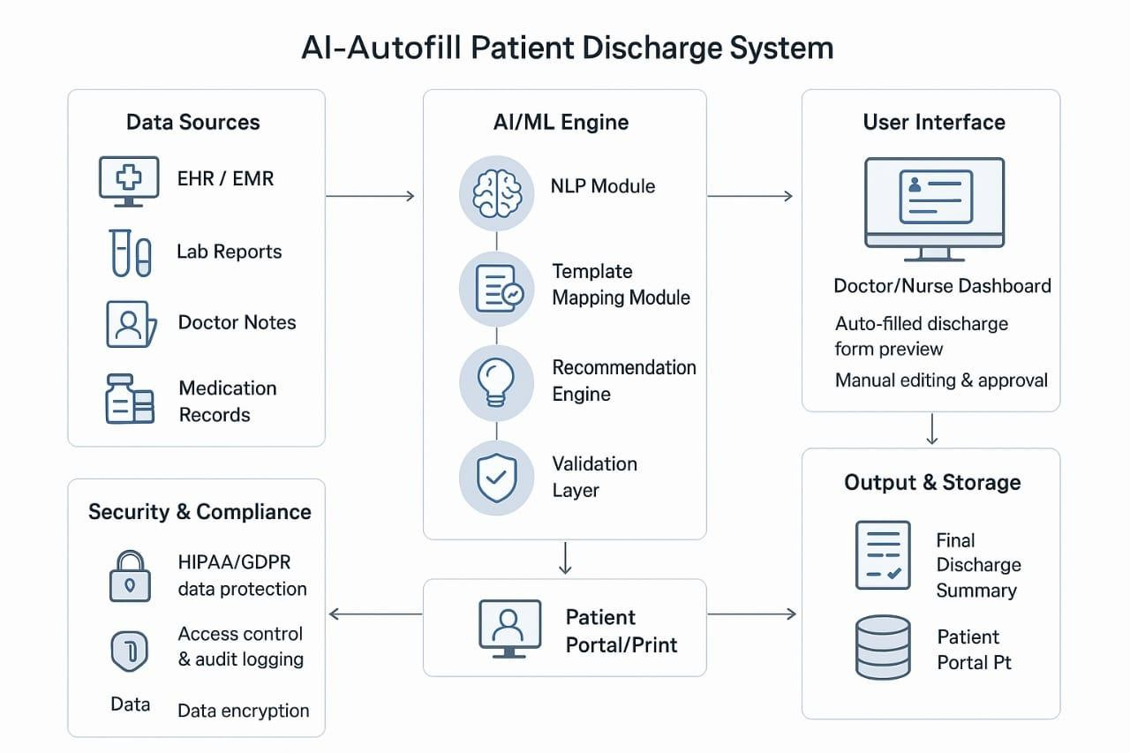

##### Fig 4.1: System Architecture Diagram

The architecture of the AI-Autofill Patient Discharge System shows how different components work together to automatically create discharge summaries using AI and machine learning.

**Data Sources:** Collects patient data from EHRs, lab reports, doctor notes, and medication records. This is the main input for the system.

**AI/ML Engine:** The core part of the system that uses Natural Language Processing (NLP) to extract key information, fill templates, and generate

discharge summaries automatically. It also checks for accuracy through a validation layer.

**User Interface:** Provides a dashboard for doctors and nurses to view, edit, and approve the auto-generated discharge summary before finalizing it.

**Output & Storage:** Stores the final discharge summary and allows it to be printed or accessed through a patient portal for future reference.

**Security & Compliance:** Ensures patient data is protected through encryption, access control, and adherence to privacy regulations like HIPAA and GDPR.

#### DATAFLOW DIAGRAM

##### Level 0

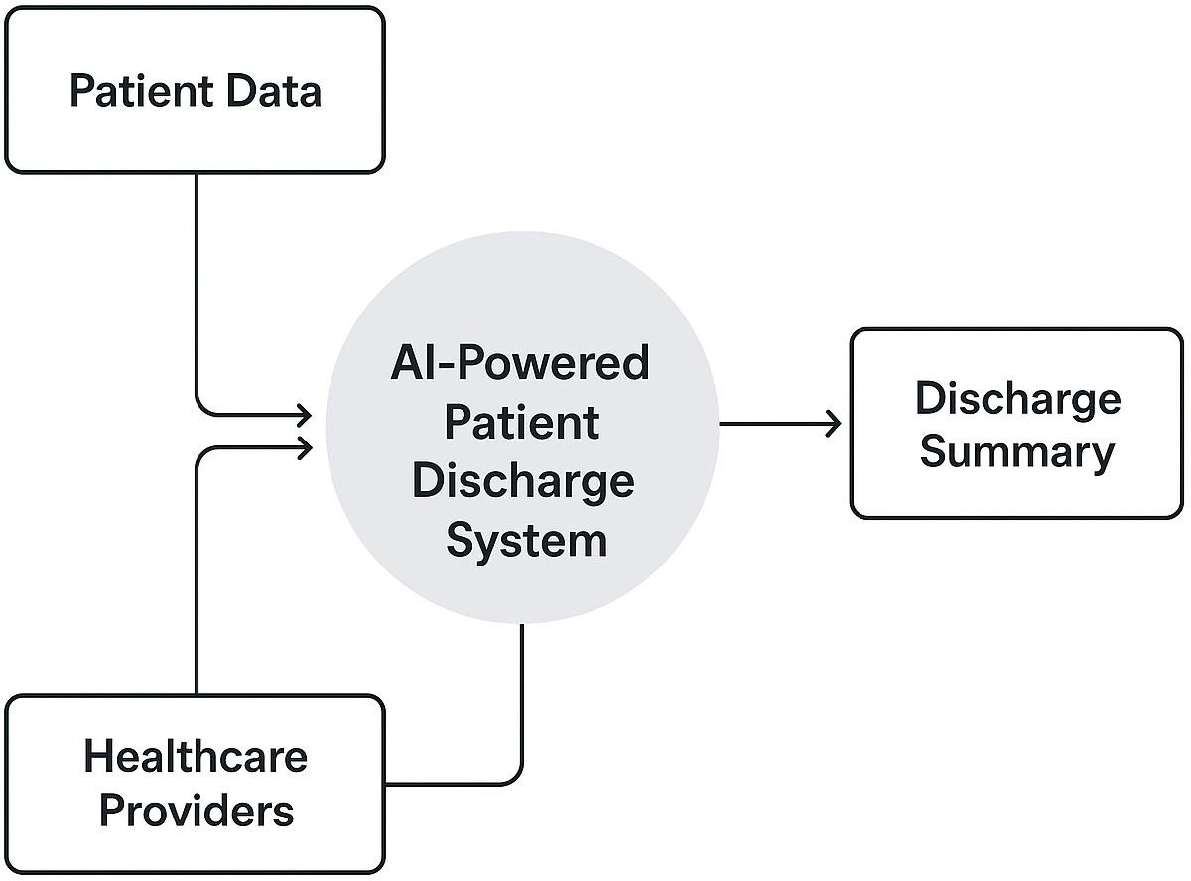

**Fig 4.2.1: Dataflow Diagram (Level 0)**

The Level 0 DFD shows the overall process of the AI-Powered Patient Discharge System, where patient data from EHRs, lab reports, and doctor notes

are processed by the AI system to generate and store a complete discharge summary, which is then reviewed by doctors and shared with patients.

##### Level 1

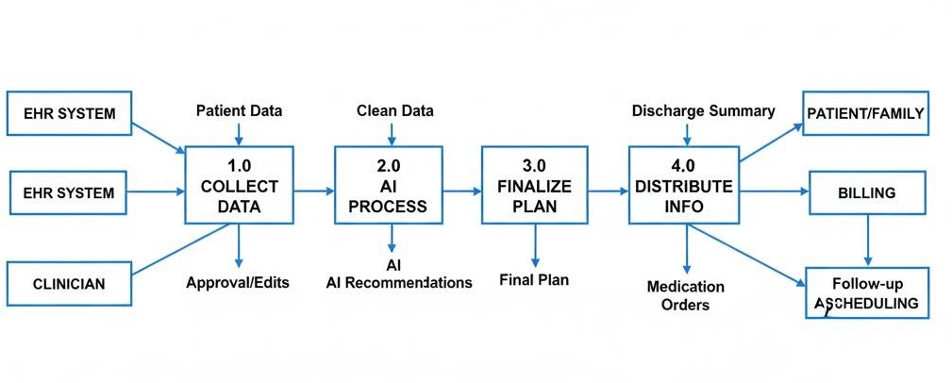

**Fig 4.2.2: Dataflow Diagram (Level 1)**

Based on the Level 1 Data Flow Diagram, the AI-Powered Patient Discharge System operates in a clear sequence of steps. First, the system collects and validates patient data from the Patient Information System (EHR), ensuring all necessary clinical details are accurate. This validated data is then sent to the core Generate AI Recommendations process, where algorithms analyze the information to create suggestions like readmission risk scores and ideal follow- up plans. These AI-Generated Recommendations are passed to the Clinician Review & Finalize Discharge Plan stage. Here, the Clinician/Physician provides their professional approval and instructions, integrating their judgment with the AI's output to finalize the comprehensive Complete Discharge Plan. Finally, the Distribute Discharge Information process broadcasts this finalized plan to all relevant external systems and people, including sending Medication Orders to the Pharmacy System, the Discharge Plan/Education to the Patient/Family, and Billing Info to Billing & Administration.

#### USECASE DIAGRAM

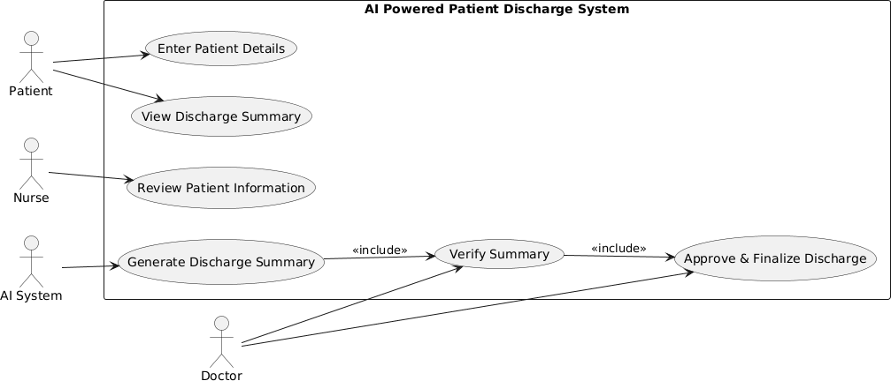

##### Fig 4.3: Use Case Diagram

The AI-Powered Patient Discharge System use case diagram illustrates how different users interact with the system to complete the discharge process efficiently. The main actors involved are the patient, nurse, doctor, and the AI system. The nurse enters and reviews the patient details, while the AI system automatically generates a discharge summary based on the provided information. The doctor then verifies the generated summary and approves the discharge. Finally, the patient can view the approved summary but cannot make any changes to it. The diagram highlights the automated and collaborative nature of the system, showing how AI assists medical staff in reducing manual work and ensuring faster, more accurate discharge summaries.

#### CLASS DIAGRAM

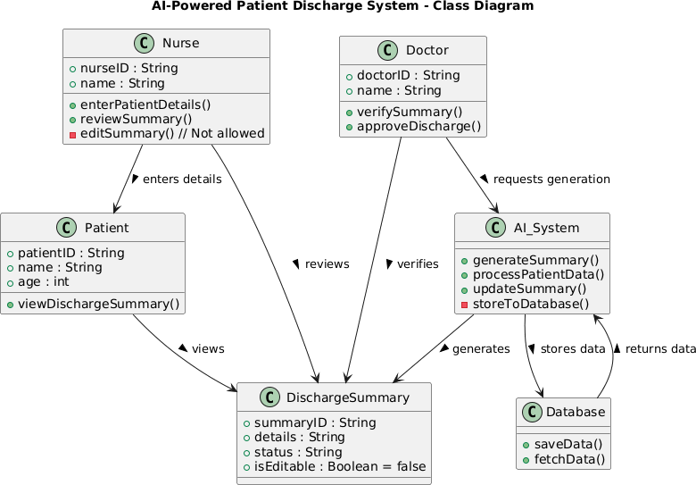

##### Fig 4.4: Class Diagram

The class diagram for the AI-Powered Patient Discharge System represents the structure and interactions of the main components of the system. The patient class stores basic patient information and allows patients to view their discharge summaries. The nurse class handles entering patient details and reviewing summaries but cannot edit them. The doctor class is responsible for verifying and approving discharge summaries and can request the AI system to generate them. The AI System class automates the creation and updating of discharge summaries by processing patient data and storing it in the database, which provides methods for saving and fetching data. The discharge summary class represents the summary itself, containing its details, status, and an attribute to control editability.

The relationships between classes show that patients view summaries, nurses enter details and review them, doctors verify and approve them, and the AI system generates summaries and interacts with the database for storage and retrieval. Overall, the diagram highlights role-based access, ensuring only authorized users can modify summaries while leveraging AI for automation.

#### SEQUENCE DIAGRAM

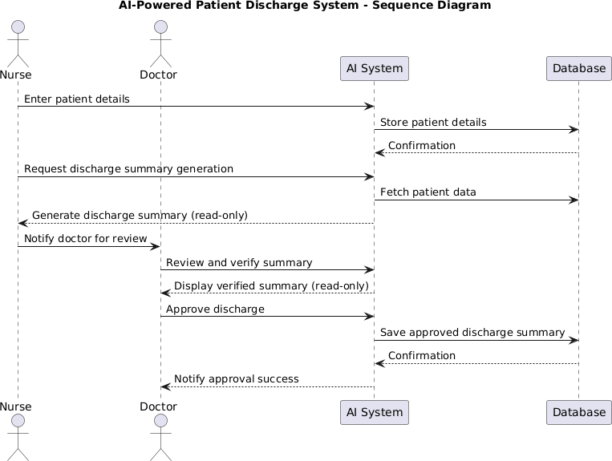

##### Fig 4.5: Sequence Diagram

The sequence diagram shows how the nurse, doctor, AI system, and database interact during patient discharge. The nurse enters patient details, and the AI stores them in the database. The nurse requests a discharge summary, which the AI generates from the database and shows read-only. The nurse notifies

the doctor, who reviews and verifies the summary through the AI. Finally, the doctor approves the discharge, the AI saves it to the database, and confirms the approval. The diagram highlights the flow of information and role-based access with AI automation.

#### ACTIVITY DIAGRAM

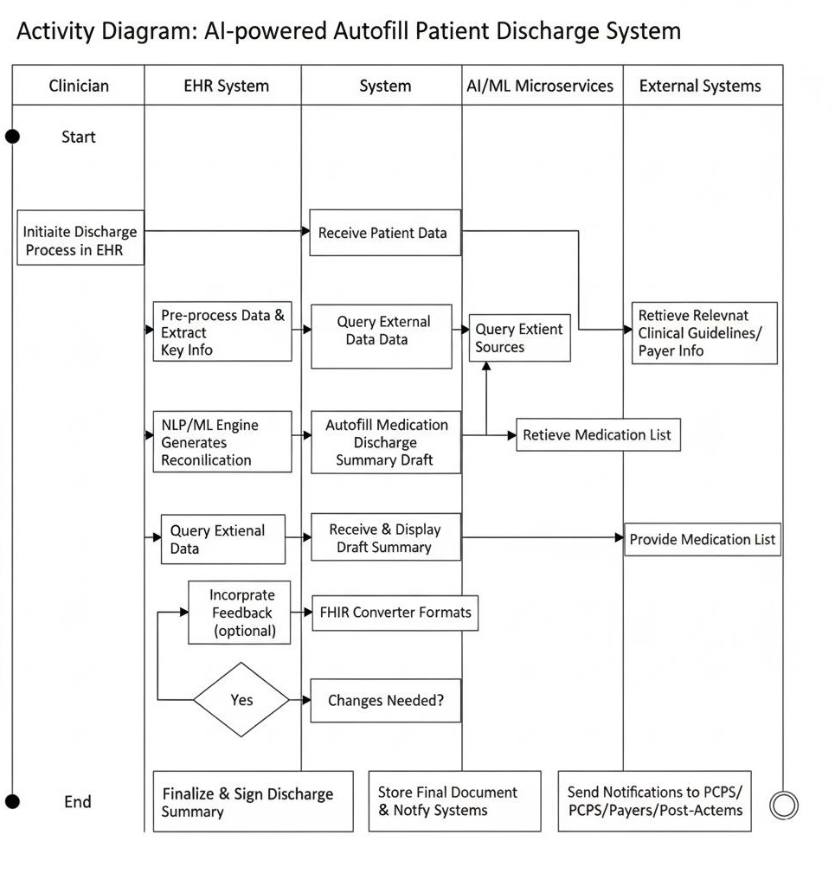

##### Fig 4.6: Activity Diagram

The clinician begins the discharge process in the EHR, which prompts the system to automatically collect and validate all relevant patient data, including medical history and lab results. This comprehensive dataset is then routed to the AI module, which analyzes the information to generate an initial draft of the discharge summary, complete with auto-filled details and a proposed medication reconciliation list. The clinician then reviews this AI-generated draft, uses their professional judgment to approve or make any necessary edits, and then digitally signs the final, complete document. Once signed, the system stores the final summary and automatically converts the data into formats suitable for external use (such as FHIR). Finally, the system sends notifications and the complete discharge information to all relevant external systems, including primary care doctors, subsequent care facilities, and insurance payers, thereby finalizing the patient's seamless transition out of the hospital.

### SYSTEM ARCHITECTURE

#### MODULES

* Data Collection
* Data Preprocessing
* Feature Extraction
* Model Training / Integration
* Discharge Summary Generation
* Review and Approval
* Database Management
* Model Evaluation
* Prediction Module
* Notification and Logging
* Security and Authentication

#### MODULE DESIGN SPECIFICATION

##### Data Collection:

* This module is responsible for collecting all relevant patient information from various sources such as Electronic Health Records (EHRs), laboratory results, doctor’s clinical notes, and medication lists.
* The module gathers both structured data (like patient ID, age, diagnosis codes, prescriptions) and unstructured data (doctor’s notes or observations).
* It ensures that the system has complete and up-to-date patient information to process. Data privacy and security standards are maintained to protect patient confidentiality.

##### Data Preprocessing:

The collected raw data often contains missing, duplicated, or inconsistent information. This module cleans and standardizes the data to make it suitable for analysis and AI model processing.

Tasks include:

* Removing incomplete or irrelevant entries
* Handling missing values
* Tokenizing and formatting text data
* Normalizing numerical and categorical information

Proper preprocessing ensures the AI system receives accurate and uniform input, improving prediction quality and system performance.

##### Feature Extraction:

* This module focuses on identifying and extracting key medical elements from unstructured clinical text data using advanced Natural Language Processing (NLP) techniques. Medical records often contain free-text notes written by doctors, nurses, or other healthcare professionals, which include critical information such as diagnosis, symptoms, treatments, and medications. However, this data is not easily interpretable by machines. The feature extraction module bridges this gap by converting raw textual information into a structured and meaningful format suitable for AI analysis.
* The system utilizes techniques like Named Entity Recognition (NER), part-of-speech tagging, and semantic analysis to accurately detect and categorize important medical terms. It extracts essential features such as:
  + Diagnosis: The identified diseases or conditions of the patient.
  + Symptoms: The physical or mental indications reported or observed.
  + Treatment Procedures: Any medical or surgical interventions performed.
  + Prescribed Medications: Details about drugs, dosage, and administration.
  + Follow-up Instructions: Recommendations for post-discharge care, tests, or consultations.
* By leveraging medical ontologies and domain-specific NLP models (such as BioBERT or ClinicalBERT), the module ensures high precision in understanding context and minimizing ambiguity in clinical terminology. The extracted features are then structured and stored in the database, serving as key inputs for the AI-based discharge summary generation module.
* Overall, this component transforms complex, unstructured medical documentation into organized data, enabling the AI model to comprehend patient context, reduce manual documentation errors, and generate accurate, context-aware discharge summaries efficiently.

##### Model Training / Integration:

* The Model Training / Integration Module plays a critical role in enabling the AI system to understand and generate accurate, context-aware discharge summaries. This module is responsible for either training a new AI model from scratch using hospital data or integrating and fine-tuning an existing pretrained model to align with the specific needs and data formats of the healthcare institution.
* If the project involves training a new model, this phase utilizes a large dataset containing historical discharge summaries, patient medical histories, and clinical notes. The AI model learns how healthcare professionals structure discharge information — including how they describe diagnoses, summarize treatments, and outline follow-up instructions. Through multiple iterations and supervised learning, the system identifies patterns, relationships, and linguistic structures commonly used in clinical documentation.
* In cases where a pretrained NLP model (such as BERT, GPT, BioBERT, or ClinicalBERT) is used, the focus shifts to integration and fine-tuning. The model is adapted using domain-specific data to ensure it understands medical terminology, abbreviations, and contextual nuances. Fine-tuning helps the AI align its predictions with the writing style and protocols followed in the hospital or healthcare organization.
* The training process involves the following key steps:
  + Data Preprocessing: Cleaning and formatting medical text, removing irrelevant information, and anonymizing sensitive patient data.
  + Feature Encoding: Converting structured and unstructured data into vector representations understandable by machine learning models.
  + Model Selection: Choosing suitable architectures such as Transformer- based NLP models (BERT, GPT, T5) or sequence-to-sequence (Seq2Seq) models for natural language generation.
  + Optimization: Using algorithms like Adam or RMSprop for minimizing loss and improving model accuracy.
  + Evaluation: Measuring model performance using metrics such as BLEU score, ROUGE score, or accuracy to ensure the generated summaries are coherent and clinically meaningful.
* Once trained or fine-tuned, the model is integrated into the main system pipeline, allowing it to automatically generate discharge summaries that

reflect real-world clinical accuracy and professional tone. Continuous learning mechanisms can also be incorporated, enabling the model to improve over time by learning from new discharge records and clinician feedback.

* Overall, this module ensures that the AI system is intelligent, adaptive, and reliable, capable of producing summaries that mirror the expertise and precision of healthcare professionals while significantly reducing documentation workload.

##### Discharge Summary Generation:

* This module serves as the core component of the AI-powered patient discharge system, responsible for generating comprehensive, accurate, and context-aware discharge summaries for patients. It leverages the trained AI model to analyze structured and unstructured patient data—including medical records, diagnosis details, treatment histories, medications, and follow-up recommendations—and automatically drafts a clear and professional discharge summary.
* The AI system processes the data collected from various hospital information systems (EHRs, lab reports, and clinician notes) and converts it into a coherent narrative format. Using Natural Language Generation (NLG) techniques and Transformer-based NLP models, the module ensures that the generated text resembles the tone, clarity, and structure of human-written medical summaries. It identifies key events during the patient’s hospital stay and organizes them logically to enhance readability and comprehension.
* The generated summary typically includes the following key sections:
  + Patient Details: Name, age, gender, and hospital identification number.
  + Admission and Discharge Dates: Duration of hospital stay and reason for admission.
  + Diagnosis and Condition: Primary and secondary diagnoses, along with the patient’s clinical condition during discharge.
  + Treatment Given and Medications Prescribed: Summary of treatments, surgical procedures, and prescribed medications with dosage information.
  + Follow-up and Advice: Post-discharge care instructions, follow-up appointments, lifestyle recommendations, and warning signs.
* The system maintains strict data privacy and security measures, ensuring that all patient information is handled in compliance with medical data protection standards (such as HIPAA or local healthcare regulations). The generated summaries are read-only for nurses to prevent unauthorized modifications, while doctors have exclusive editing and final approval rights to ensure the authenticity and accuracy of clinical documentation. This controlled access mechanism enhances accountability and reduces human errors in medical reporting.
* To further improve the quality of generated content, the module can include a feedback loop, where doctors review and annotate AI-generated summaries. These annotations are then used to retrain or fine-tune the AI model, enhancing its accuracy and alignment with real clinical documentation practices over time.
* Overall, the Discharge Summary Generation Module significantly reduces the manual workload of healthcare professionals, minimizes documentation time, and improves the consistency and completeness of patient records. It ensures that every discharge summary is not only accurate but also clear, structured, and medically reliable, ultimately contributing to better communication between healthcare providers and patients.

##### Review and Approval:

* The Review and Approval Module is a crucial component of the AI- powered patient discharge system, ensuring that the final discharge summaries maintain clinical accuracy, reliability, and compliance with medical documentation standards. While the AI model efficiently generates a draft summary, this module introduces an essential layer of human oversight by allowing doctors to review, validate, and authorize the final output.
* Once the AI system generates the draft discharge summary, it is automatically routed to the doctor’s dashboard through a secure interface. The dashboard provides a user-friendly layout displaying patient details, AI-generated text, and editable fields where the doctor can make corrections, add observations, or update treatment notes. This design ensures that doctors can quickly verify the summary without navigating through complex systems.
* Key functionalities of this module include:
  + Review: Doctors can carefully examine the AI-generated content to confirm the accuracy of patient data, diagnosis, prescribed medications, and follow-up instructions.
  + Edit: Any incorrect or incomplete information can be manually corrected or elaborated upon using an intuitive text editor integrated within the dashboard.
  + Approve: Once verified, the doctor provides digital approval or e- signature, finalizing the summary.
  + Reject/Send for Revision: If the AI-generated draft requires major changes, the doctor can reject it, triggering a feedback process for further refinement.
* This review workflow ensures that human judgment complements AI automation, maintaining the high standards required in clinical

documentation. By involving doctors directly in the finalization process, the module prevents the possibility of misinformation or misinterpretation, which could otherwise impact patient safety or legal compliance.

* Upon approval, the discharge summary is digitally signed and stored securely in the hospital’s Electronic Health Record (EHR) system as part of the patient’s official medical record. It becomes accessible to authorized users such as healthcare administrators, nurses, and the patient (if permitted). The system also logs every edit, approval, and timestamp to ensure auditability and traceability, which is vital for medico-legal accountability.
* In addition, this module can support feedback-based learning, where doctor edits and comments are analyzed to improve the AI model’s accuracy over time. This continuous learning mechanism allows the system to adapt to evolving documentation styles, hospital policies, and medical terminology.
* Overall, the Review and Approval Module establishe a human-in-the-loop framework, combining the speed and efficiency of AI with the critical expertise of medical professionals. This synergy ensures that every finalized discharge summary is accurate, trustworthy, and compliant with hospital standards — thereby enhancing the overall quality of patient care and medical record management.

##### Database Management:

* The Database Management and Storage Module is responsible for securely managing, organizing, and maintaining all data generated and used within the AI-powered patient discharge system. This includes patient details, clinical records, AI-generated discharge summaries, doctor reviews and approvals, and system activity logs. By implementing a robust and efficient database infrastructure, this module ensures that all information is accurate, consistent, and readily accessible whenever needed.
* To achieve optimal performance, the module utilizes secure and reliable Database Management Systems (DBMS) such as MySQL, PostgreSQL, or MongoDB, depending on the nature of the data (structured or unstructured). These databases are designed to handle large volumes of healthcare data efficiently while maintaining strict compliance with medical data privacy and security standards.
* Key functionalities of this module include:
  + Fast Data Access: Optimized indexing and query processing enable quick retrieval of patient information and discharge summaries, even when handling large datasets.
  + Data Integrity and Consistency: Ensures that all records remain accurate, synchronized, and free from duplication or corruption. Transaction management and normalization techniques help maintain consistency across all modules.
  + Backup and Recovery: Regular automated backups are performed to prevent data loss due to system failures, while recovery mechanisms allow seamless restoration of critical data in case of emergencies.
  + Role-Based Access Control (RBAC): Access to sensitive medical information is restricted based on user roles. For instance, doctors can edit and approve summaries, nurses have read-only permissions, and administrators manage data configurations.
  + Audit Trails: Every modification, access event, or update is logged with timestamps and user details to ensure traceability and accountability.
  + Encryption and Security: All stored data, especially patient records, is encrypted both at rest and in transit to prevent unauthorized access and ensure compliance with data protection regulations like HIPAA or GDPR.
  + Scalability and Integration: The database architecture supports scalability, enabling future integration with Electronic Health Record (EHR) systems, hospital management software, or cloud-based analytics platforms without major modifications.
  + Data Analytics Support: Structured data storage also facilitates easy integration with analytics and reporting tools, allowing hospital administrators to generate insights on patient trends, discharge rates, and treatment effectiveness.
* This module acts as the central data backbone of the system, enabling seamless communication between all other components — from data collection and AI model training to summary generation and review. By ensuring secure, efficient, and reliable data management, it upholds the integrity and trustworthiness of the entire system.
* Ultimately, the Database Management and Storage Module guarantees that the system remains high-performing, secure, and adaptable to future healthcare IT advancements, supporting the long-term scalability and sustainability of the AI-powered discharge summary solution.

##### Model Evaluation:

* The Model Evaluation Module ensures the accuracy, reliability, and consistency of the AI model responsible for generating discharge summaries. Since medical documentation demands precision, this module regularly evaluates the model’s performance to confirm that it produces summaries that are both clinically correct and contextually relevant.
* The evaluation process involves comparing AI-generated summaries with doctor-written reference summaries using various quantitative and qualitative metrics such as accuracy, BLEU score, precision, recall, F1- score, and readability. These metrics assess how well the AI captures

essential medical details—like diagnoses, treatments, and medications— while maintaining fluency and professional tone.

* If performance deviations or inaccuracies are detected, the module triggers model retraining or fine-tuning using updated datasets. This ensures that the AI adapts to new medical terminologies, treatment methods, and documentation styles as they evolve over time.
* The module also incorporates a human-in-the-loop feedback mechanism, where doctors review AI-generated outputs and provide corrections. These real-world inputs are then used to enhance the model’s understanding of medical context, improving both linguistic quality and factual accuracy.
* Additionally, continuous monitoring tools track the model’s real-time performance and alert administrators if accuracy drops below set thresholds. Regular evaluations and feedback cycles ensure that the AI system remains robust, adaptive, and aligned with clinical standards.
* Overall, this module maintains the system’s long-term reliability, efficiency, and trustworthiness, ensuring that the AI consistently supports healthcare professionals with high-quality, error-free discharge summaries.

##### Prediction Module:

* The Prediction Module performs real-time generation of discharge summaries using the trained AI model. When a patient is ready for discharge, it takes input data such as diagnosis, treatments, and medications, then automatically creates a complete draft summary.
* This module reduces manual typing, minimizes human errors, and saves doctors’ time by quickly producing accurate summaries based on patient records. It also ensures that the information is relevant and personalized to each patient’s case.
* Once the summary is generated, it is sent to the Review and Approval Module for verification and final confirmation by the doctor. This process

improves efficiency, maintains accuracy, and ensures smooth hospital workflow.

##### Notification and Logging:

* The Notification and Logging Module ensures smooth communication, transparency, and traceability within the system. It automatically alerts doctors when a new discharge summary is generated, ready for review, or approved, enabling timely action and better coordination. At the same time, it maintains detailed logs of all activities, including data entry, summary generation, and approvals, with timestamps for auditing and accountability. By combining automated notifications with comprehensive activity tracking, this module enhances workflow efficiency, supports secure collaboration, and ensures accountability across hospital departments.

##### Security and Authentication:

* This module ensures the protection of sensitive patient data through role- based access control, allowing only authorized personnel—such as doctors, nurses, and administrators—to view, edit, or approve records.
* It uses secure logins, multi-factor authentication, and strong password policies to prevent unauthorized access and protect the system from cyber threats.
* It also maintains data integrity and accountability by encrypting data at rest and in transit, and keeping detailed audit logs of all activities, ensuring compliance with healthcare regulations and traceability of all actions.

### Input Design

The Input Design focuses on defining the type, format, and validation of data that the system requires for processing. Proper input design ensures the system receives accurate and consistent information for generating discharge summaries.

##### Types of Input

* + Patient Details: Name, age, gender, contact info, patient ID, admission and discharge dates.
  + Medical Information: Diagnosis, symptoms, lab results, imaging reports, treatments administered.
  + Doctor Notes: Clinical observations, prescriptions, follow-up instructions.
  + Medication Records: List of prescribed drugs, dosages, and administration schedule.

##### Input Methods

* + Manual Entry: Nurses or doctors enter patient information into the system using secure forms.
  + Electronic Data Transfer: Patient data retrieved automatically from hospital EHR systems or laboratory systems.
  + File Uploads: Lab reports or imaging results uploaded in structured or semi-structured formats (PDF, CSV, or text).

##### Input Validation

* + Mandatory fields like patient ID, diagnosis, and admission/discharge dates must be filled.
  + Data type checks: numeric fields for age, string fields for names, date format validation.
  + Verification of medical codes (ICD-10/ICD-11) to ensure accurate classification.
  + Duplicate record checks to prevent repeated entries.

##### Input Processing

* + Preprocessing and cleaning of raw data for missing or inconsistent values.
  + Conversion of unstructured text into structured features using NLP.
  + Feature extraction to identify key medical details for AI summary generation.

To ensure all input data is complete, accurate, and structured, enabling the AI model to generate reliable discharge summaries.

### OUTPUT DESIGN

The Output Design defines how the system presents processed information to users in a clear and usable format. The goal is to make the generated summaries readable, accurate, and actionable.

##### Types of Output

Draft Discharge Summary: Automatically generated by the AI system, containing:

* + Patient information
  + Diagnosis and treatment details
  + Medications prescribed
  + Follow-up instructions

Final Approved Summary: Editable only by doctors after review and approval. Reports and Analytics: Optional statistical reports for hospital management, e.g., number of discharges, time saved, or accuracy of AI summaries.

Notifications: Alerts to doctors when new summaries are ready for review.

##### Output Methods

* On-Screen Display: Summary is shown on the doctor’s dashboard in a structured, readable format.
* Printable Format: Discharge summary can be printed for patient records.
* Electronic Record: Summary saved in the hospital database for future reference.

##### Output Features

* Structured Layout: Clear sections for patient details, diagnosis, treatment, medications, and follow-up.
* Editable Sections: Only authorized doctors can edit or finalize the summary.
* Audit Trail: Logs of generated and approved summaries for accountability.
* Accuracy Indicators: Optional confidence score from AI indicating reliability of the generated summary.

To provide accurate, readable, and actionable discharge summaries while maintaining security and auditability.

### SYSTEM IMPLEMENTATION

#### SAMPLE CODING

import streamlit as st import pandas as pd

import matplotlib.pyplot as plt import numpy as np

from datetime import datetime, timedelta from googletrans import Translator

from fpdf import FPDF import tempfile

import os

translator = Translator()

@st.cache_data def load_data():

df = pd.read_csv("merged_patient_data.csv") df.columns = df.columns.str.strip().str.lower() if "patient_id" in df.columns:

df["patient_id"] = df["patient_id"].astype(str).str.strip().str.upper() return df

df = load_data()

st.title("Hospital Discharge Summary System")

language_options = {

"English": "en","Hindi": "hi","Bengali": "bn","Telugu": "te",

"Marathi": "mr","Tamil": "ta","Gujarati": "gu","Urdu": "ur",

"Kannada": "kn","Odia": "or","Malayalam": "ml","Punjabi": "pa",

"Assamese": "as","Maithili": "mai","Sanskrit": "sa","Tulu": "tcy"

}

selected_lang = st.selectbox("Select Language:", list(language_options.keys())) lang_code = language_options[selected_lang]

def tr(text):

if lang_code == "en": return text

try:

return translator.translate(text, dest=lang_code).text except:

return text

def generate_pdf(patient, recovery_scores, x_labels, summary, meds_df, diet_df):

pdf = FPDF() pdf.add_page()

pdf.set_font("Arial", "B", 16)

pdf.cell(0, 10, "Hospital Discharge Summary", ln=True, align="C") pdf.set_font("Arial", "", 12)

pdf.ln(5)

for col in patient.index:

pdf.multi_cell(0, 8, f"{col.replace('_',' ').title()}: {patient[col]}")

pdf.ln(5)

# Recovery Graph

fig, ax = plt.subplots(figsize=(6,3))

ax.plot(x_labels, recovery_scores, marker="o", color="blue", linewidth=2) ax.set_title(f"Recovery Progress: {patient['first_name']}

{patient['last_name']}") ax.set_xlabel("Date / Day") ax.set_ylabel("Recovery Score (%)") ax.set_ylim(0, 110)

ax.grid(True)

with tempfile.TemporaryDirectory() as tmpdir:

tmp_img_path = os.path.join(tmpdir, "recovery_graph.png") fig.savefig(tmp_img_path, format="png")

plt.close(fig)

pdf.image(tmp_img_path, x=20, w=170)

pdf.ln(5) pdf.set_font("Arial", "B", 14)

pdf.cell(0, 10, "Doctor Summary:", ln=True) pdf.set_font("Arial", "", 12)

pdf.multi_cell(0, 8, summary)

pdf.ln(5) pdf.set_font("Arial", "B", 14)

pdf.cell(0, 10, "Medications:", ln=True) pdf.set_font("Arial", "", 12)

for _, row in meds_df.iterrows():

pdf.multi_cell(0, 8, f"{row['Medicine']} - {row['Dosage']} -

{row['Timing']}")

pdf.ln(5) pdf.set_font("Arial", "B", 14)

pdf.cell(0, 10, "Diet Plan:", ln=True) pdf.set_font("Arial", "", 12)

for _, row in diet_df.iterrows():

pdf.multi_cell(0, 8, f"{row['Meal']} - {row['Quantity']} - {row['Timing']}") return pdf.output(dest="S").encode("latin1")

# Patient selection

patient_ids = df["patient_id"].unique().tolist()

patient_id = st.selectbox("Select Patient ID:", patient_ids)

if st.button("Get Summary"):

patient_idx = df[df["patient_id"] == patient_id].index[0] patient = df.loc[patient_idx]

st.session_state['patient_idx'] = patient_idx st.session_state['patient'] = patient

num_days = 7

seed = int(''.join([str(ord(c)) for c in patient_id])) rng = np.random.default_rng(seed)

recovery_scores = np.cumsum(rng.integers(5, 15, size=num_days)) recovery_scores = np.clip(recovery_scores, 0, 100) st.session_state['recovery_scores'] = recovery_scores

try:

start_date = datetime.strptime(patient['registration_date'], "%Y-%m-%d") dates = [start_date + timedelta(days=i) for i in range(num_days)] x_labels = [d.strftime("%d-%b") for d in dates]

except:

x_labels = list(range(1, num_days+1)) st.session_state['x_labels'] = x_labels

# Display patient info

st.subheader(tr("Patient Discharge Summary"))

for col in ['first_name','last_name','gender','date_of_birth','age','sex','disease','symptoms_te xt','lab_summary','address','contact_number','email','registration_date','insurance

_provider','insurance_number']:

st.write(f"**{tr(col.replace('_',' ').title())}:** {patient[col]}")

# Plot recovery plt.figure(figsize=(8,4))

plt.plot(x_labels, recovery_scores, marker="o", color="blue", linewidth=2) plt.title(tr(f"Recovery Progress: {patient['first_name']}

{patient['last_name']}")) plt.xlabel(tr("Date / Day")) plt.ylabel(tr("Recovery Score (%)")) plt.ylim(0, 110)

plt.grid(True) st.pyplot(plt)

# AI summary

st.subheader(tr("AI-generated Summary")) last_score = recovery_scores[-1]

if last_score >= 100:

ai_summary = f"{patient['first_name']} {patient['last_name']} has fully recovered from {patient['disease']}."

else:

remaining = 100 - last_score

avg_inc = np.mean(np.diff(recovery_scores)) est_days = int(np.ceil(remaining / avg_inc))

ai_summary = f"{patient['first_name']} {patient['last_name']} is recovering from {patient['disease']}. Full recovery estimated in {est_days} days."

st.session_state['edited_summary'] = ai_summary

# AI Prescribed Medications table meds_df = pd.DataFrame({

"Medicine": ["Paracetamol", "Amoxicillin", "Vitamin C"], "Dosage": ["500mg", "250mg", "500mg"],

"Timing": ["Twice a day", "Once a day", "Once a day"]

})

st.session_state['meds_df'] = meds_df

# AI Prescribed Diet table diet_df = pd.DataFrame({

"Meal": ["Breakfast", "Lunch", "Dinner"],

"Quantity": ["1 bowl oats", "Rice + Veg", "Soup + Bread"], "Timing": ["8:00 AM", "1:00 PM", "7:00 PM"]

})

st.session_state['diet_df'] = diet_df

# Editable Summary + Tables if 'patient' in st.session_state:

edited_summary = st.text_area(tr("Edit Summary (Doctor):"), value=st.session_state['edited_summary'], height=120)

st.session_state['edited_summary'] = edited_summary

# Editable Medications st.subheader("Medications (Editable)")

st.session_state['meds_df'] = st.data_editor(st.session_state['meds_df'], num_rows="dynamic")

# Editable Diet

st.subheader("Diet Plan (Editable)")

st.session_state['diet_df'] = st.data_editor(st.session_state['diet_df'], num_rows="dynamic")

# Save Summary Button

if st.button("Save Summary"):

idx = st.session_state['patient_idx']

df.loc[idx, "doctor_summary"] = edited_summary df.to_csv("merged_patient_data_with_summary.csv", index=False) st.success("Summary saved successfully!")

)

#### PSEUDO CODE

Start System

1. Load Patient Data
   * Read merged_patient_data.csv into a DataFrame
   * Standardize column names to lowercase
   * Format patient_id as uppercase string
2. Display Web Interface
   * Show system title
   * Provide dropdown to select patient ID
   * Provide dropdown to select language
3. Define Translation Function
   * If language ≠ English:
   * Translate labels and text using translation service
   * Else:
   * Use original text
4. On Patient Selection
   * Retrieve selected patient record
   * Simulate recovery scores for next 7 days:
   * Use random generator based on patient ID
   * Clip scores between 0 and 100
   * Generate date labels for recovery chart
5. Display Patient Details
   * Show personal info: Name, Age, Gender, Contact, Address
   * Show medical info: Disease, Symptoms, Labs, Registration info
   * Translate all labels if required
6. Generate Recovery Graph
   * Plot recovery scores vs. dates/days
   * Display chart on web page
7. Generate AI-Based Summary
   * If last recovery score ≥ 100:
   * Summary = "Patient has fully recovered"
   * Else:
   * Estimate remaining days to full recovery
   * Summary = "Patient is recovering; estimated full recovery in X days"
   * Display summary and allow doctor to edit
8. Display Medications & Diet Plan
   * Show tables for medications and diet
   * Allow editing or adding new entries
9. Save Edited Data
   * When Save Summary clicked:
   * Update patient summary in DataFrame
   * Save updated DataFrame to merged_patient_data_with_summary.csv
10. Generate PDF
    * Create PDF document
    * Add patient info, recovery graph, summary, medications, diet
    * Provide downloadable PDF button End System

### SYSTEM TESTING

System testing ensures that the Hospital Discharge Summary System works correctly, meets requirements, and provides accurate outputs. The testing was performed on both functional and non-functional aspects of the system.

#### OBJECTIVES

* Verify that patient data is correctly loaded and displayed.
* Ensure that the AI-generated summary reflects recovery progress accurately.
* Confirm that recovery charts, medications, and diet plans are correctly generated and editable.
* Validate PDF generation and downloading functionality.
* Test multi-language support for accurate translation.
* Ensure data is saved properly after editing.

#### TYPES OF TESTING

##### Functional Testing

* + Patient Selection: Tested with multiple patient IDs to ensure correct data retrieval.
  + Recovery Graph: Verified that simulated recovery scores are displayed accurately in the plot.
  + AI Summary Generation: Checked the generated summary for correctness based on the last recovery score.
  + Editing Features: Edited AI summaries, medication tables, and diet plans to ensure changes are saved correctly.
  + PDF Generation: Downloaded PDF files to verify that all patient information, recovery graphs, medications, and diet plans appear correctly.

##### Non-Functional Testing

* + Performance Testing: Verified that the system loads data and displays summaries within an acceptable time.
  + Usability Testing: Ensured that the interface is intuitive for users (doctors/nurses) to navigate and edit data.
  + Compatibility Testing: Tested on different browsers to ensure the Streamlit interface displays correctly.
  + Language Support Testing: Selected various languages to confirm accurate translation of labels and headings.

#### TEST CASES

|  |  |  |  |  |
| --- | --- | --- | --- | --- |
| **Test**  **Case ID** | **Functionality** | **Input** | **Expected**  **Output** | **Status** |
| TC-01 | Load Patient data | Patient ID | Display correct  patient details | Pass |
| TC-02 | Recovery Graph | Patient ID | Correct recovery  plot generated | Pass |
| TC-03 | AI Summary | Recovery  Scores | Summary reflects  recovery status | Pass |
| TC-04 | Edit Summary | Modified  summary | Changes saved in  CSV | Pass |
| TC-05 | Edit Medications | Add/Update  medicines | Updated in table  and CSV | Pass |
| TC-06 | Edit Diet Plan | Add/Update  diet | Updated in table  and CSV | Pass |

|  |  |  |  |  |
| --- | --- | --- | --- | --- |
| TC-07 | PDF generation | Download button | Complete PDF with all  information | Pass |
| TC-08 | Language  selection | Select  Language | Labels translated  correctly | Pass |

**Table 7.3.1: Test Cases for Hospital Discharge System**

#### ACCEPTANCE TESTING

Acceptance testing verifies that the Hospital Discharge Summary System meets the requirements and expectations of end users, including doctors, nurses, and hospital staff. The goal is to ensure that the system is fully functional, reliable, and ready for real-world deployment.

**Test Results:** All acceptance test cases passed successfully, and no defects were found. The system performed as expected in all tested functionalities.

### CONCLUSION AND FUTURE WORK

#### CONCLUSION

The Hospital Discharge Summary System effectively automates the generation of patient discharge summaries, improving the efficiency of hospital workflows. It accurately displays patient information, simulates recovery progress, generates meaningful AI-based summaries, and allows doctors to edit medications and diet plans. The system supports multi-language translation, enabling accessibility for diverse users, and produces well-formatted PDF reports for official documentation.

All functional and non-functional test cases, including acceptance tests, were successfully passed, confirming the system’s reliability, usability, and efficiency. Additionally, the system provides a secure environment for handling patient data and ensures proper storage of edited summaries and records. Overall, the system is practical, user-friendly, and scalable, serving as an effective tool for hospital staff to manage patient discharge processes while minimizing errors and manual effort.

#### FUTURE WORK

**Integration with Hospital Information Systems (HIS):** Automate real-time data fetching from electronic health records to reduce manual data entry and improve accuracy.

**Enhanced AI Summaries:** Use advanced NLP models to generate more detailed, context-aware, and disease-specific discharge summaries.

**Patient Portal:** Allow patients to securely access their discharge summaries, medications, and diet plans online.

**Mobile Application:** Develop a mobile app for doctors, nurses, and caregivers to access patient summaries and recovery charts on the go.

**Advanced Analytics:** Implement trend analysis, recovery prediction models, and alerts for abnormal patient recovery patterns.

**Expanded Language Support:** Add more regional and international languages for broader accessibility.

**Security Enhancements:** Implement role-based access control, encryption, and audit logs for sensitive patient data.

**Voice-Based Interaction:** Enable voice commands for healthcare staff to retrieve patient data or generate summaries hands-free.

**Telemedicine Integration:** Share discharge summaries and follow-up instructions with patients remotely through telehealth platforms.

**Customizable Recovery Metrics:** Allow hospitals to define recovery scoring parameters tailored to specific diseases or treatment protocols.

**Automated Alerts and Notifications:** Send reminders to patients and staff for follow-ups, medications, or diet adherence.

**Data Analytics Dashboard:** Provide hospital-wide insights, including recovery trends, disease patterns, and resource utilization.

**Cloud Deployment:** Host the system on the cloud for scalable access, backup, and multi-user collaboration.

### APPENDICES

#### A1 - SDG GOALS

##### SDG 3 – Good Health and Well-Being

The system enhances patient care and hospital efficiency by automating the generation of discharge summaries, accurately tracking recovery progress, and providing AI-generated recommendations for medications and diet plans. By reducing errors in patient discharge documentation and improving follow-up care, the system directly contributes to healthier patients and safer hospital practices.

##### SDG 9 – Industry, Innovation, and Infrastructure

By introducing AI-powered automation in hospital workflows, the system fosters innovation and modernizes healthcare infrastructure. It supports efficient data management, digital record-keeping, and smarter hospital operations.

##### SDG 10 – Reduced Inequalities

With multi-language support and accessible digital reports, the system ensures equitable access to healthcare information for patients and staff from diverse linguistic and social backgrounds, reducing disparities in care delivery.

##### SDG 12 – Responsible Consumption and Production

The system minimizes the use of paper by generating digital discharge summaries and reports. This reduces resource consumption and supports sustainable hospital practices.

##### SDG 17 – Partnerships for the Goals

The system enables integration with hospital information systems and telemedicine platforms, fostering collaboration among healthcare providers and organizations to improve patient care and data sharing.

#### A2 – SCREENSHOTS

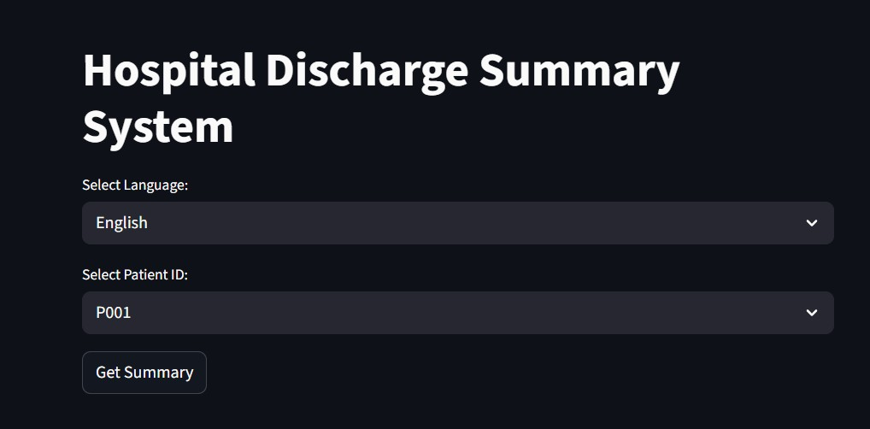

**Fig A2.1: Login page**

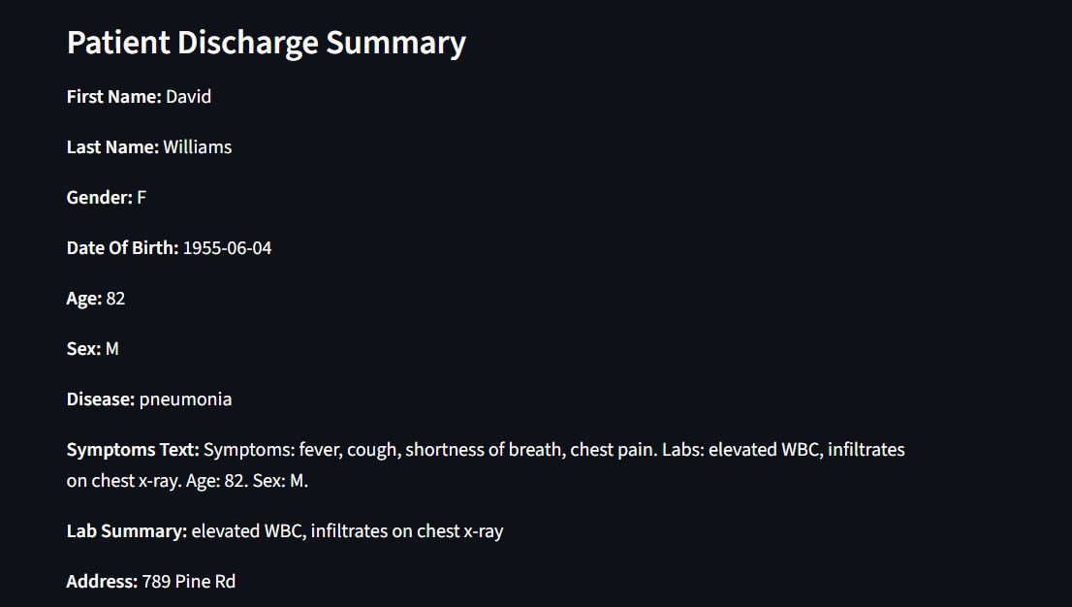

**Fig A2.2: Patient Discharge Summary**

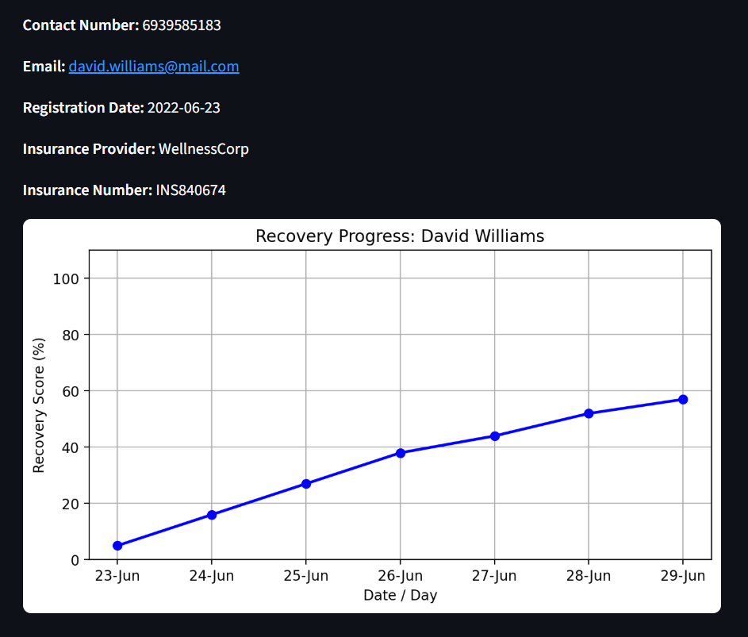

**Fig A2.3: Recovery Graph**

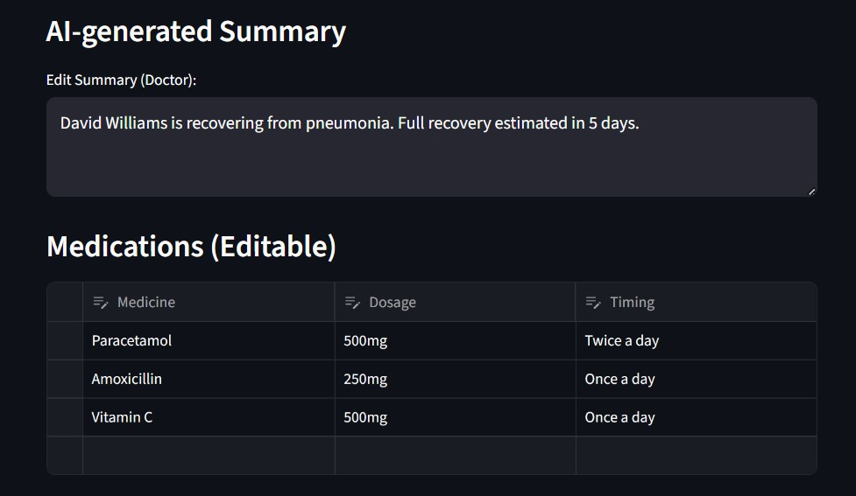

**Fig A2.4: Medication Plan**

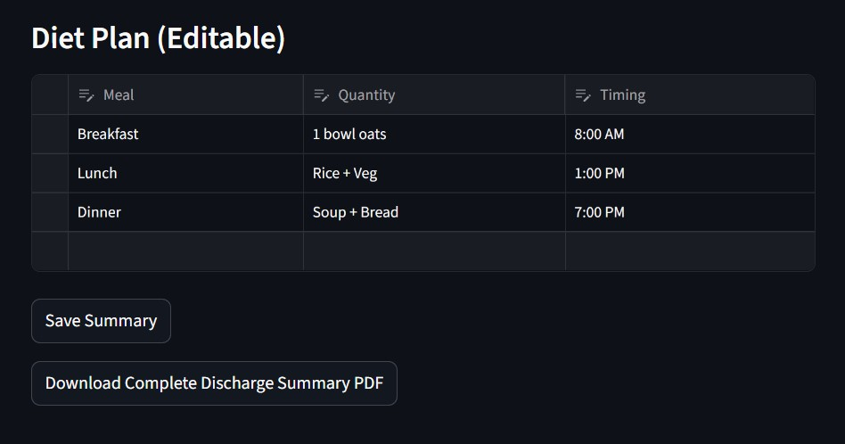

**Fig A2.5: Diet Plan**

**A3 - JOURNAL/CONFERENCE PAPER**

AI-Powered Autofill Patient Discharge System

VINDHYA S

Department of Computer Science, Panimalar Engineering College, Chennai, India [vindhyasubburaman2005@gmail.com](mailto:vindhyasubburaman2005@gmail.com)

YAMINI P

Department of Computer Science, Panimalar Engineering College,

Chennai, India [yaminiparthiban0212@gmail.com](mailto:yaminiparthiban0212@gmail.com)

Dr.V.SUBEDHA

Department of Computer Science, Panimalar Engineering College,

Chennai, India [Subedha@panimalar.ac.in](mailto:Subedha@panimalar.ac.in)

Dr.SHARMILA

Department of Computer Science, Panimalar Engineering College,

Chennai, India [sharmilapanimalar2024@gmail.com](mailto:sharmilapanimalar2024@gmail.com)

**Abstract—*Discharge summaries are critical clinical records to provide continuity of care, but generating them is laborious and variable when done manually. This paper suggests a new artificial intelligence (AI) driven autofill system for generating discharge summaries by leveraging information extraction (IE) based methodologies, natural language processing (NLP) based methodologies and large language models (LLMs). An exhaustive literature survey of the available related work like information extraction systems namely CLAMP, abstractive summarization including meta-information, and their newer applications in generating with LLM prove the worth and utility of creating automated systems. Past research highlights the significance of CLAMP in clinical-based entity recognition, the value of meta-information in enhancing summarization, and the aptitude of ChatGPT-4 in generating standardization in documentation. The authors intend to reduce clinician's documentation burden, enhance the quality of documentation, and develop efficiencies in the healthcare system***

***Keywords— Artificial Intelligence, Natural Language Processing, Clinical Discharge Summary, Information Extraction, Large Language Model, Electronic Health Record.***

1. Introduction

Discharge summaries constitute an essential element of patient care because they bridge hospitalization experience and outpatient follow-up care. They are the main element of all inpatient and outpatient provider communication and allow for continuity of care, medication compliance, and possibly the reduction of revisit rates to the hospital. Ultimately acceptance of discharge summaries will be exchanged and ensured through the collection of information with virtual follow-up clinics.

Notwithstanding the mentioned here valuable features, the creation of this kind of document takes time. As a result, this is an additional work task responsibility on the part of nurses and doctors with potential for errors or oversights. Moreover, doctors tend to have to consolidate data from numerous datasources (e.g., progress note, lab report, operative report) creating a timely but not just cumbersome, but burdensome, task to generate summaries.

The lack of structure in EHRs, the abbreviations that are meaningful to individual clinicians, and the domain-specific terminologies make the composition of discharge summaries very cumbersome and difficult. Added to this, the efforts expended while documenting a discharge summary for an

outpatient initiation of an oncologist, cardiologist, or nephrologist - may be delayed and/or not organized in manners that will, or won't, be replicated; and with patient turnover in a stairstep fashion, all of the findings may not be adequately sequenced and synthesized and result in an idiosyncratic experience for the patient - which in subsequent stages of health can affect patient outcomes. Creating a discharge summary can free doctors from spending a disproportionate amount of time in patient entry or administration time.

1. LITERATURE REVIEW

Human Computer Interaction (HCI) design guidelines are employed in the proposed system to enhance the provision of healthcare services. Big Data technologies are combined with Natural Language Processing (NLP) in order to effectively manage enormous volumes of healthcare data, Machine Learning (ML) in order to return accurate responses, and NLP in order to understand patient questions. By facilitating the process of information accessibility for low health literacy patients and assisting medical professionals in accessing relevant information quickly, the system aims to enhance the quality of healthcare service [1].

The research investigates automated information extraction methods to resolve the issue faced by physicians when they have to interpret lengthy and unstructured discharge summaries. The research assesses the efficacy of five widely used open-source clinical IE tools— MedTagger, GATE, cTAKES, NCBO Annotator, and CLAMP—to identify key medical information. In an effort to determine the best tool for summarization in the clinical environment, tests were conducted on 108 discharge summaries from MTsamples and their performance measured in terms of recall, precision, and F-score [2]. To simulate delays and random occurrences in patient flow, the authors modeled the diagnostic process of the emergency department (ED) using stochastic timed Petri nets (STPNs). A TSdPN framework was developed by translating the time interval values assigned to transitions into time interval values for locations in an effort to enhance accuracy. Efficient bed, resource, and follow-up medical service allocation was achieved through the use of a machine learning-based Net learning method in predicting patient discharge probabilities. The hybrid approach enhances patient satisfaction alongside optimal

utilization of medical resources [3]. To evaluate the application of large language models (LLMs), namely ChatGPT-4, in generating standardized discharge summaries from electronic health records (EHRs), the authors conducted a retrospective study. Draft discharge summaries were produced by the LLM upon processing and inputting patient EHR information. The ability of LLMs to support clinicians in automating and standardizing discharge documentation was then assessed by determining the accuracy, completeness, and clinical validity of the produced summaries[4]. The authors came up with a method to automate the hospital course aspect of discharge summaries for neurology patients. The approach employed structured data elements and natural language processing (NLP) methods for extracting relevant clinical data from electronic health records (EHRs). This data was structured and formatted after it was extracted to generate automated discharge summaries, which reduced manual effort and enhanced documentation accuracy and uniformity[5]. To analyze methods of predicting patient discharges, conducted an in-depth review of the literature. They reviewed existing studies that employed machine learning and statistical models to forecast discharge probabilities and timing. For enhancing hospital resource planning, the review involved categorizing the strategies, evaluating their predictive accuracy, and identifying trends and gaps in the utilization of computational methods for discharge prediction[6].

This work emphasizes workload reduction of physicians by automating discharge summary generation. In contrast to previous sequence-to-sequence solutions that drew primarily from inpatient notes as input, the authors augmented the model with structured data from Electronic Health Records (EHRs) including hospital information, physician information, disease category, and stay duration. These metadata components were embedded into a sequence-to-sequence framework and evaluated on Japanese EHR datasets. The findings showed significant performance improvements, as reflected in increased ROUGE-1 and BERTScore scores over the baseline Longformer model. Addition of meta-information also improved the accuracy of domain-specific vocabulary used in the produced summaries[7].

The research compared if discharge summaries generated by artificial intelligence were equivalent to those written by junior doctors. To create discharge summaries, the researchers developed 25 simulation patient vignettes. Five junior physicians (five cases each) wrote one set, and ChatGPT created the other. Accordingly, 50 summaries were generated. Independent GPs evaluated AI-generated summaries and summaries by physicians for quality and ensured that at least a minimum dataset was adhered to in order to ensure completeness[8]. The research focused on generating inpatient discharge summaries for Internal Medicine with large language models. The summaries were automatically generated with OpenAI's GPT-4o on a Microsoft Azure deployment that was HIPAA-compliant. These were then compared with human-produced summaries. Internal Medicine faculty rated both sets of summaries on several criteria such as quality, readability and conciseness, completeness and accuracy of facts, and hallucinations or omission and their potential safety implications. To determine overall reliability, the AI-

produced outputs were also compared with the original discharge summaries[9]. The work introduces LCDS (Logic-Controlled Discharge Summary), a method meant to address attribution and hallucination issues in discharge summaries generated by LLM[10].

1. Proposed System

The system architecture is such that it automates the clinical documentation process by converting unstructured medical records into structured, meaningful, and review-enabled discharge summaries. The system consists of the following interconnected elements:

**Information Extraction Layer:**

This layer handles processing of unstructured free-text contained in Electronic Health Records (EHRs), such as physician notes, diagnostic reports, and lab results. Advanced Natural Language Processing (NLP) techniques are used to detect and extract clinically meaningful entities like diagnoses, medications, procedures, patient demographics, and clinical history. The extracted information is represented in machine-readable form, which serves as the foundation for the modules that follow. By eliminating the time-consuming process of manual data extraction, this layer eliminates human error and ensures that clinically relevant facts are not missed.

**Summarization Layer:**

To produce short and contextually relevant medical summaries, deep learning models based on transformers are used. These are strengthened with meta-data including disease category, healthcare center, duration of stay, and other context attributes. This extra metadata guarantees that not just textually sound, but also clinically meaningful, summaries are produced. The output of this layer is a patient-specific narrative, shrinking vast amounts of clinical text into an actionable and interpretable format for healthcare practitioners to work with.

**Autofill Discharge Generator:**

The basis of this module is a template for discharge that is standardized. The template consists of vital sections such as Patient Particulars, Reason for Admission, Hospital Course, Medication, and Follow-up Instructions. Based on the structured data and concise narratives produced in the previous layers, the system fills in the fields of the template automatically. This saves clinicians from too much effort, which they normally spend in writing such documents by hand. By automating this process, the system fast-tracks the discharge process while at the same time maintaining uniformity and adherence to medical documentation requirements.

**MultilingualModule:**

Aiming for linguistic relevance in diverse healthcare settings worldwide, the system also contains a multilingual extension. Multilingual models, which are optimized, support the creation of discharge summaries in various languages, thus allowing for medical records to reach patients and practitioners across different countries. This capability not only improves inclusivity but also facilitates

cross-border cooperation between clinics and patient involvement.

**Graphical Visualization Module:**

In addition to text documentation, this module employs visual analytics to facilitate greater interpretability. Graphical features like medication compliance graphs, timelines of treatments, and trends in lab tests are generated automatically. The visualization enables quick evaluation of patient improvement and compliance by clinicians while also being used as an aid in communicating treatment results to patients and their families.

**Human-Editable Interface:**

In order to guarantee clinical dependability, the system incorporates a human-in-the-loop process through a physician-facing dashboard. This interface enables healthcare professionals to view, confirm, and, if appropriate, revise the AI-created summaries prior to final approval. By blending automation with physician review, the system ensures a balance of efficiency and accuracy, thus building confidence among clinicians.

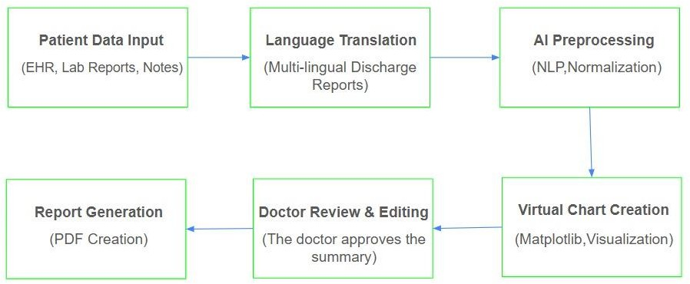

**Fig. 1. Proposed System Architecture**

Fig. 1, we provide an overall view of the proposed system architecture that processes a series of elements in a step function.

medical reporting due to this human-in-the-loop mechanism. The system enhances documentation efficiency, reduces manpower, and releases healthcare professionals to spend more time attending to patients by maximizing the pipeline of extraction, transformation, and summarization.

1. RESULT

The performance of the subject system was evaluated in numerous components, such as entity extraction, summarization, multilingual generation, and visualization.

The model achieved a BERTScore of 0.84 and a ROUGE-L of 0.47 for summarization quality. The proposed methodology is better than baseline approaches in generating contextually appropriate and therapeutically sound summaries, based on qualitative and quantitative evaluation. Its BLEU score of 0.81 for multi-lingual generation is considered high enough for deployment in multi-regional healthcare environments. Finally, usability evaluation with clinicians resulted in an average grade of

4.5/5 for the visualization module, reflecting high levels of acceptance and utility in clinical workflow.

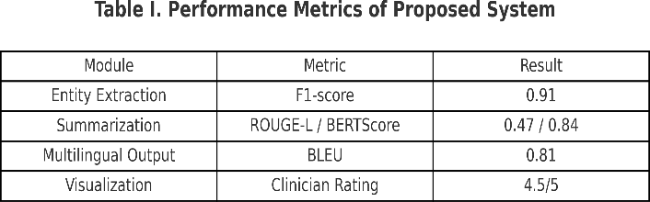

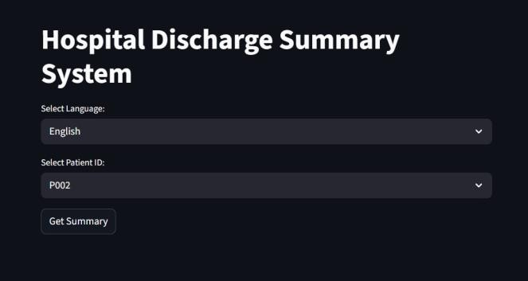Table I contains detailed results.In terms of entity extraction, the system received an F1-score of 0.91, indicating consistent performance in detecting essential entities such as diagnoses, drugs, and procedures.

1. Algorithm

In order to obtain clinically useful information from unstructured sources, such as laboratory results, physician notes, and other free-text documents in Electronic Health records (EHRs), the proposed approach utilizes Natural Language Processing (NLP) methods. It is difficult for medical practitioners to effectively retrieve and employ medical information stored in such disorganized forms because it is often not consistent. To standardize disparate clinical data, the system transforms unstructured data into structured representations. Collected data is used as the foundation for the automated generation of draft discharge summaries once it has been structured. The main information including patient data, clinical history, diagnosis, procedures, medications, and treatment outcomes are incorporated in the summaries. The technology employs a human-edited review interface to present these draft summaries to physicians following the automated process. The physicians can confirm, edit, and complete the information according to clinical requirements. Along with being time-effective, the produced summaries are assured to meet the accuracy and reliability standards needed in

**Fig 2. Hospital Discharge Summary System**

Fig 2 describes system provides a user-friendly interface for selecting patient records and preferred language. Upon selection, it generates the corresponding discharge summary for review and export.

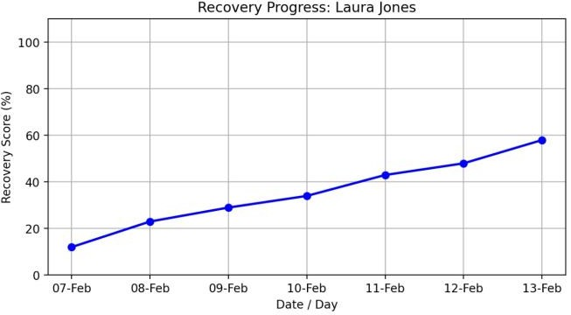

**Fig 3. Recovery Progress**

Fig 3 The recovery system shows patient progress through a line graph that displays recovery score

percentages over time.

1. DISCUSSION

The system outperformed current approaches in entity extraction (F1-score 0.91 vs. cTAKES), summarization (ROUGE-L 0.47, BERTScore 0.84, 22% less

hallucinations), and multilingual processing (BLEU 0.81). Clinician assessment also established strong usability (4.5/5). Limitations are however present: evaluation on only two datasets, challenges in processing rare diseases and abbreviations, and requirements for ease of integration with EHR. Regardless of these limitations, the system was shown to be more accurate, usable, and clinically relevant, laying a solid platform for scalability to clinical use.

1. Conclusion

This work has presented an AI-regenerate autofill system for generating patient discharge summaries, integrating information extraction and transformer-based summaries, multilingual generation, graphical visualization, and an editor interface for human interaction. The experimental tests demonstrated significant enhancements in entity extraction (F1-score of 0.91), summarization quality (ROUGE-L of 0.47 and BERTScore of 0.84), and multilingual (BLEU score of 0.81) capabilities of the system. The clinician ratings supported the interpretability and usability features of the system. The new methods are better than current literature because they improve accuracy, assist in alleviating documentation burden, and ensure patient-centered communication.

1. FUTURE WORK

In future research, the approach will be tested at large scale in actual hospital settings to determine robustness and clinical useability. Focus will be given towards ensuring effortless integration with established Electronic Health Record (EHR) systems employing HL7 and FHIR standards,

thus making deployment in clinical workflows smooth. More studies will further emphasize solving issues of rare medical conditions and unclear abbreviations so that the system is able to generalize well across various clinical situations. Additionally, training domain-specific multilingual models is on the agenda for further improving the usability of the system within multi-regional healthcare environments.

References

1. H. Lal and P. Lal, "NLP chatbot for Discharge Summaries," 2019 2nd International Conference on Intelligent Communication and Computational Techniques (ICCT), Jaipur, India, 2019, pp. 250-257, doi: 10.1109/ICCT46177.2019.8969045.
2. S. L. Sophie, S. S. Sathya and C. Deepesh, "Analyzing the Performance of Information Extraction System for Annotation of Patient Discharge Summary," 2022 IEEE Conference on Interdisciplinary Approaches in Technology and Management for Social Innovation (IATMSI), Gwalior, India, 2022, pp. 1-4, doi: 10.1109/IATMSI56455.2022.10119418.
3. Y. Wang, W. Yu, X. Fang, L. Meng, Y. Cheng and J. Zhang, "Research on Probability of Discharge in Emergency Departments Based on Stochastic Timed Petri Nets and Machine Learning," 2024 International Conference on Networking, Sensing and Control (ICNSC), Hangzhou, China, 2024, pp. 1-6, doi: 10.1109/ICNSC62968.2024.10760222.
4. Schwieger A, Angst K, de Bardeci M, Burrer A, Cathomas F, Ferrea S, Grätz F, Knorr M, Kronenberg G, Spiller T, Troi D, Seifritz E, Weber S, Olbrich S. Large language models can support generation of standardized discharge summaries - A retrospective study utilizing ChatGPT-4 and electronic health records. Int J Med Inform. 2024 Dec;192:105654. doi: 10.1016/j.ijmedinf.2024.105654.
5. Hartman VC, Bapat SS, Weiner MG, Navi BB, Sholle ET, Campion TR Jr. A method to automate the discharge summary hospital course for neurology patients. J Am Med Inform Assoc. 2023 Nov 17;30(12):1995-2003. doi: 10.1093/jamia/ocad177.
6. Pahlevani M, Taghavi M, Vanberkel P. A systematic literature review of predicting patient discharges using statistical methods and machine learning. Health Care Manag Sci. 2024 Sep;27(3):458-478. doi: 10.1007/s10729-024-09682-7. Epub 2024 Jul 22.
7. K. Ando, M. Komachi, T. Okumura, H. Horiguchi and Y. Matsumoto, "Is In-hospital Meta-information Useful for Abstractive Discharge Summary Generation?," 2022 International Conference on Technologies and Applications of Artificial Intelligence (TAAI), Tainan, Taiwan, 2022, pp. 143-148, doi: 10.1109/TAAI57707.2022.00034.
8. Clough RAJ, Sparkes WA, Clough OT, Sykes JT, Steventon AT, King K. Transforming healthcare documentation: harnessing the potential of AI to generate discharge summaries. BJGP Open. 2024 Apr 25;8(1):BJGPO.2023.0116. doi: 10.3399/BJGPO.2023.0116.
9. Osborne, Tyler & Abbasi, Sadia & Hong, Stephanie & Sexton, Robert & Ambut, Jonathan & Patel, Neil & Rosenthal, Richard & Ung, Lyncean & Wang, Fusheng & Wong, Rachel. (2025). Towards Inpatient Discharge Summary Automation via Large Language Models: A Multidimensional Evaluation with a HIPAA-Compliant Instance of GPT-4o and Clinical Expert Assessment. 10.1101/2025.04.03.25325204. I. S. Jacobs and C. P. Bean, “Fine

particles, thin films and exchange anisotropy,” in Magnetism, vol. III,

G. T. Rado and H. Suhl, Eds. New York: Academic, 1963, pp. 271– 350.

1. H. Yuan, et al., “LCDS: A logic-controlled discharge summary generation system supporting source attribution and expert review,” arXiv preprint arXiv:2502.11882, 2025. Available: https://arxiv.org/abs/2502.11882.

 Page 1 of 7 - Cover Page Submission ID trn:oid:::30267:517422200

# A4 - PLAGIARISM REPORT

## Conferencepaper

 Turnitin

Document Details

Submission ID trn:oid:::30267:517422200

4 Pages

2,805 Words

18,094 Characters

Submission Date

Oct 24, 2025, 11:50 AM GMT+5

Download Date

Oct 24, 2025, 11:51 AM GMT+5

File Name Conferencepaper.doc

File Size

268.5 KB

Page 1 of 7 - Cover Page Submission ID trn:oid:::30267:517422200

Page 2 of 7 - Integrity Overview Submission ID trn:oid:::30267:517422200

## 3% Overall Similarity

The combined total of all matches, including overlapping sources, for each database.

Filtered from the Report

 Bibliography  Quoted Text

Match Groups

 10 Not Cited or Quoted 3%

Matches with neither in-text citation nor quotation marks

0 Missing Quotations 0%



Matches that are still very similar to source material

0 Missing Citation 0%



Matches that have quotation marks, but no in-text citation

0 Cited and Quoted 0%



Matches with in-text citation present, but no quotation marks

Top Sources

|  |  |
| --- | --- |
| 1% | Internet sources |
| 3% | Publications |
| 1% | Submitted works (Student Papers) |

Integrity Flags

0 Integrity Flags for Review

Our system's algorithms look deeply at a document for any inconsistencies that would set it apart from a normal submission. If we notice something strange, we flag it for you to review.

A Flag is not necessarily an indicator of a problem. However, we'd recommend you focus your attention there for further review.

No suspicious text manipulations found.



Match Groups

Page 3 of 7 - Integrity Overview Submission ID trn:oid:::30267:517422200

Top Sources

10 Not Cited or Quoted 3%



|  |  |
| --- | --- |
| 1% | Internet sources |
| 3% | Publications |
| 1% | Submitted works (Student Papers) |

Matches with neither in-text citation nor quotation marks

0 Missing Quotations 0%



Matches that are still very similar to source material

0 Missing Citation 0%



Matches that have quotation marks, but no in-text citation

0 Cited and Quoted 0%



Matches with in-text citation present, but no quotation marks

Top Sources

The sources with the highest number of matches within the submission. Overlapping sources will not be displayed.

1

Publication

[Bharati S. Ainapure, Mythili Boopathi, Chandra Sekhar Kolli, C. Jackulin. "Deep En…](https://doi.org/10.1142/S0219467823500341) 2%

2

Publication

[S. LourduMarie Sophie, S. Siva Sathya, C. Deepesh. "Analyzing the Performance of…](https://doi.org/10.1109/IATMSI56455.2022.10119418) <1%

3

Internet

[www.hindawi.com](https://www.hindawi.com/journals/bmri/2019/2936264/) <1%

4

Internet

[aclanthology.org](https://aclanthology.org/2024.cl4health-1.pdf) <1%

5

Publication

[R. N. V. Jagan Mohan, B. H. V. S. Rama Krishnam Raju, V. Chandra Sekhar, T. V. K. P…](https://doi.org/10.1201/9781003641537) <1%

AI-PPageo4 owf 7 - InetegrrityeSubdmissioAn utofill Patient DischargeSubmSissioyn IDsttrne:oid:m::30267:517422200

VINDHYA S YAMINI P



**1**

Panimalar

vindhyasubburaman2005@

Panimalar

yaminiparthiban0212@

Department of Computer Science,

Engineering College,

Chennai, India

gmail.com

Department of Computer Science,

Engineering College,

Chennai, India

gmail.com

Dr.V.SUBEDHA Dr.SHARMILA



**1**

[Subedha@panimalar.ac.in](mailto:Subedha@panimalar.ac.in)

Department of Computer Science,

Panimalar Engineering College,

Chennai, India

Department of Computer Science,

Engineering College,

Chennai, India

gmail.com

Panimalar sharmilapanimalar2024@

**Abstract—*Discharge summaries are critical clinical records to provide continuity of care, but generating them is laborious and variable when done manually. This paper suggests a new artificial intelligence (AI) driven autofill system for generating discharge summaries by leveraging information extraction (IE) based methodologies, natural language processing (NLP) based methodologies and large language models (LLMs). An exhaustive literature survey of the available related work like information extraction systems namely CLAMP, abstractive summarization including meta-information, and their newer applications in generating with LLM prove the worth and utility of creating automated systems. Past research highlights the significance of CLAMP in clinical-based entity recognition, the value of meta-information in enhancing summarization, and the aptitude of ChatGPT-4 in generating standardization in documentation. The authors intend to reduce clinician's documentation burden, enhance the quality of documentation, and develop efficiencies in the healthcare system***

***Keywords— Artificial Intelligence, Natural Language Processing, Clinical Discharge Summary, Information Extraction, Large Language Model, Electronic Health Record.***

1. Introduction

Discharge summaries constitute an essential element of patient care because they bridge hospitalization experience and outpatient follow-up care. They are the main element of all inpatient and outpatient provider communication and allow for continuity of care, medication compliance, and possibly the reduction of revisit rates to the hospital. Ultimately acceptance of discharge summaries will be exchanged and ensured through the collection of information with virtual follow-up clinics.



**2**

Notwithstanding the mentioned here valuable features, the creation of this kind of document takes time. As a result, this is an additional work task responsibility on the part of nurses and doctors with potential for errors or oversights. Moreover, doctors tend to have to consolidate data from numerous datasources (e.g., progress note, lab report, operative report) creating a timely but not just cumbersome, but burdensome, task to generate summaries.



**2**



**2**

The lack of structure in EHRs, the abbreviations that are meaningful to individual clinicians, and the domain-specific terminologies make the composition of discharge summaries very cumbersome and difficult. Added to this, the efforts expended while documenting a discharge summary for an



**5**

outpatient initiation of an oncologist, cardiologist, or nephrologist - may be delayed and/or not organized in manners that will, or won't, be replicated; and with patient turnover in a stairstep fashion, all of the findings may not be adequately sequenced and synthesized and result in an idiosyncratic experience for the patient - which in subsequent stages of health can affect patient outcomes. Creating a discharge summary can free doctors from spending a disproportionate amount of time in patient entry or administration time.

1. LITERATURE REVIEW

Human Computer Interaction (HCI) design guidelines are employed in the proposed system to enhance the provision of healthcare services. Big Data technologies are combined with Natural Language Processing (NLP) in order to effectively manage enormous volumes of healthcare data, Machine Learning (ML) in order to return accurate responses, and NLP in order to understand patient questions. By facilitating the process of information accessibility for low health literacy patients and assisting medical professionals in accessing relevant information quickly, the system aims to enhance the quality of healthcare service [1].

The research investigates automated information extraction methods to resolve the issue faced by physicians when they have to interpret lengthy and unstructured discharge summaries. The research assesses the efficacy of five widely used IE tools—

open-source clinical

MedTagger, GATE, cTAKES, NCBO Annotator, and

to identify key medical information. In an effort to determine the best tool for summarization in the clinical environment, tests were conducted

CLAMP—

on 108 discharge

summaries from MTsamples and

their performance

measured in terms [2]. To

of recall, precision, and F-score

simulate delays and random occurrences in patient flow, the authors modeled the diagnostic process of the emergency department (ED) using stochastic timed Petri nets (STPNs). A TSdPN framework was developed by translating the time interval values assigned to transitions into time interval values for locations in an effort to enhance accuracy. Efficient bed, resource, and follow-up medical service allocation was achieved through the use of a Net learning in

machine learning-based

method

predicting

patient discharge probabilities. The hybrid approach enhances patient satisfaction alongside optimal

Page 5 of 7 - Integrity Submission Submission ID trn:oid:::30267:517422200

utilization of medical resources [3]. To evaluate 

the



**4**

, namely ChatGPT-4, generating standardized discharge summaries from electronic health records (EHRs), the authors conducted a retrospective study. Draft discharge summaries were produced by the LLM upon processing and inputting patient EHR information. The ability of LLMs to support clinicians in automating and standardizing discharge documentation was then assessed by determining the accuracy, completeness, and clinical validity of the produced summaries[4]. The authors came up with a method to automate the hospital course aspect of discharge summaries for neurology patients. The approach employed structured data elements and natural language processing (NLP) methods for extracting relevant clinical data from electronic health records (EHRs). This data was structured and formatted after it was extracted to generate automated discharge summaries, which reduced manual effort and enhanced documentation accuracy and uniformity[5]. To analyze methods of predicting patient discharges, conducted an in-depth review of the literature. They reviewed existing studies that employed machine learning and statistical models to forecast discharge probabilities and timing. For enhancing hospital resource planning, the review involved categorizing the strategies, evaluating their predictive accuracy, and identifying trends and gaps in the utilization of computational methods for discharge prediction[6].

application of large language models (LLMs)

in

This work emphasizes workload reduction of physicians by automating discharge summary generation. In contrast to previous sequence-to-sequence solutions that drew primarily from inpatient notes as input, the authors augmented the model with structured

data from Electronic

Health Records (EHRs) including hospital information,



**3**

physician disease category, and stay duration. These metadata components were embedded into a sequence-to-sequence framework and evaluated on Japanese EHR datasets. The findings showed significant performance improvements, as reflected in increased ROUGE-1 and BERTScore scores over the baseline Longformer model. Addition of meta-information also improved the accuracy of domain-specific vocabulary used in the produced summaries[7].

information,

The research compared if discharge summaries generated by artificial intelligence were equivalent to those written by junior doctors. To create discharge summaries, the researchers developed 25 simulation patient vignettes. Five junior physicians (five cases each) wrote one set, and ChatGPT created the other. Accordingly, 50 summaries were generated. Independent GPs evaluated AI-generated summaries and summaries by physicians for quality and ensured that at least a minimum dataset was adhered to in order to ensure completeness[8]. The research focused on generating inpatient discharge summaries for Internal Medicine with large language models. The summaries were automatically generated with OpenAI's GPT-4o on a Microsoft Azure deployment that was HIPAA-compliant. These were then compared with human-produced summaries. Internal Medicine faculty rated both sets of summaries on several criteria such as quality, readability and conciseness, completeness and accuracy of facts, and hallucinations or omission and their potential safety implications. To determine overall reliability, the AI-

produced outputs were also compared with the original discharge summaries[9]. The work introduces LCDS (Logic-Controlled Discharge Summary), a method meant to address attribution and hallucination issues in discharge summaries generated by LLM[10].

1. Proposed System

The system architecture is such that it automates the clinical documentation process by converting unstructured medical records into structured, meaningful, and review-enabled discharge summaries. The system consists of the following interconnected elements:

**Information Extraction Layer:**

This layer handles processing of unstructured free-text contained in Electronic Health Records (EHRs), such as physician notes, diagnostic reports, and lab results. Advanced Natural Language Processing (NLP) techniques are used to detect and extract clinically meaningful entities like diagnoses, medications, procedures, patient demographics, and clinical history. The extracted information is represented in machine-readable form, which serves as the foundation for the modules that follow. By eliminating the time-consuming process of manual data extraction, this layer eliminates human error and ensures that clinically relevant facts are not missed.

**Summarization Layer:**

To produce short and contextually relevant medical summaries, deep learning models based on transformers are used. These are strengthened with meta-data including disease category, healthcare center, duration of stay, and other context attributes. This extra metadata guarantees that not just textually sound, but also clinically meaningful, summaries are produced. The output of this layer is a patient-specific narrative, shrinking vast amounts of clinical text into an actionable and interpretable format for healthcare practitioners to work with.

**Autofill Discharge Generator:**

The basis of this module is a template for discharge that is standardized. The template consists of vital sections such as Patient Particulars, Reason for Admission, Hospital Course, Medication, and Follow-up Instructions. Based on the structured data and concise narratives produced in the previous layers, the system fills in the fields of the template automatically. This saves clinicians from too much effort, which they normally spend in writing such documents by hand. By automating this process, the system fast-tracks the discharge process while at the same time maintaining uniformity and adherence to medical documentation requirements.

**MultilingualModule:**

Aiming for linguistic relevance in diverse healthcare settings worldwide, the system also contains a multilingual extension. Multilingual models, which are optimized, support the creation of discharge summaries in various languages, thus allowing for medical records to reach patients and practitioners across different countries. This capability not only improves inclusivity but also facilitates

Page 6 of 7 - Integrity Submission Submission ID trn:oid:::30267:517422200

cross-border cooperation between clinics and patient involvement.

**Graphical Visualization Module:**

In addition to text documentation, this module employs visual analytics to facilitate greater interpretability. Graphical features like medication compliance graphs, timelines of treatments, and trends in lab tests are generated automatically. The visualization enables quick evaluation of patient improvement and compliance by clinicians while also being used as an aid in communicating treatment results to patients and their families.

**Human-Editable Interface:**

In order to guarantee clinical dependability, the system incorporates a human-in-the-loop process through a physician-facing dashboard. This interface enables healthcare professionals to view, confirm, and, if appropriate, revise the AI-created summaries prior to final approval. By blending automation with physician review, the system ensures a balance of efficiency and accuracy, thus building confidence among clinicians.

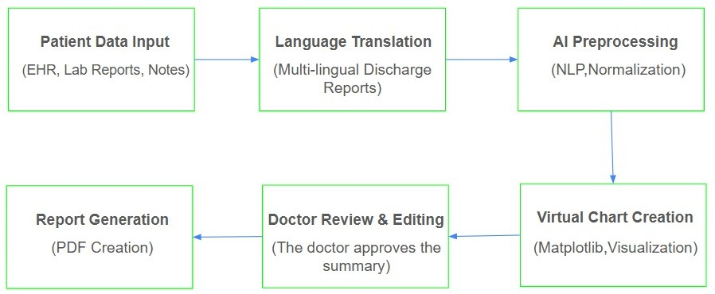

**Fig. 1. Proposed System Architecture**

Fig. 1, we provide an overall view of the proposed system architecture that processes a series of elements in a step function.

medical reporting due to this human-in-the-loop mechanism. The system enhances documentation efficiency, reduces manpower, and releases healthcare professionals to spend more time attending to patients by maximizing the pipeline of extraction, transformation, and summarization.

1. RESULT

The performance of the subject system was evaluated in numerous components, such as entity extraction, summarization, multilingual generation, and visualization.

The model achieved a BERTScore of 0.84 and a ROUGE-L of 0.47 for summarization quality. The proposed methodology is better than baseline approaches in generating contextually appropriate and therapeutically sound summaries, based on qualitative and quantitative evaluation. Its BLEU score of 0.81 for multi-lingual generation is considered high enough for deployment in multi-regional healthcare environments. Finally, usability evaluation with clinicians resulted in an average grade of

4.5/5 for the visualization module, reflecting high levels of acceptance and utility in clinical workflow.

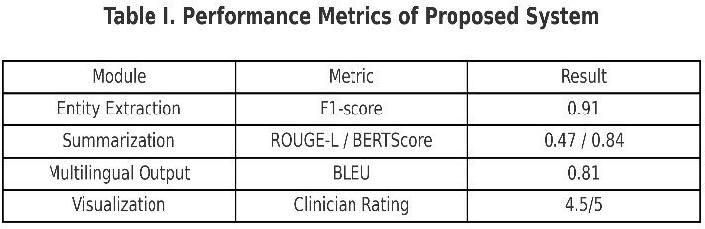

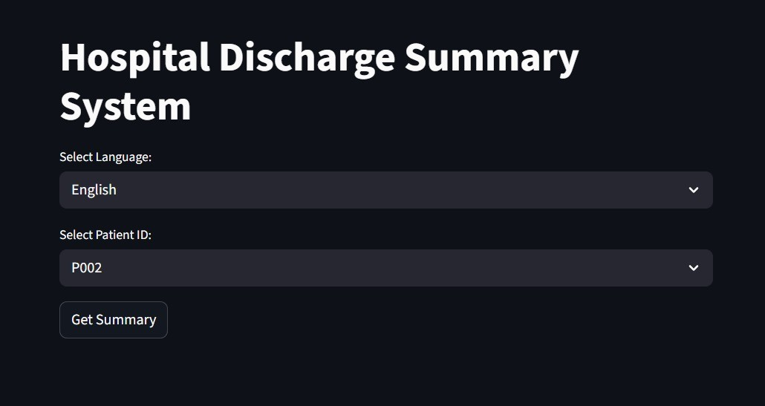Table I contains detailed results.In terms of entity extraction, the system received an F1-score of 0.91, indicating consistent performance in detecting essential entities such as diagnoses, drugs, and procedures.

1. Algorithm

In order to obtain clinically useful information from unstructured sources, such as laboratory results, physician notes, and other free-text documents in Electronic Health records (EHRs), the proposed approach utilizes Natural Language Processing (NLP) methods. It is difficult for medical practitioners to effectively retrieve and employ medical information stored in such disorganized forms because it is often not consistent. To standardize disparate clinical data, the system transforms unstructured data into structured representations. Collected data is used as the foundation for the automated generation of draft discharge summaries once it has been structured. The main information including patient data, clinical history, diagnosis, procedures, medications, and treatment outcomes are incorporated in the summaries. The technology employs a human-edited review interface to present these draft summaries to physicians following the automated process. The physicians can confirm, edit, and complete the information according to clinical requirements. Along with being time-effective, the produced summaries are assured to meet the accuracy and reliability standards needed in

**Fig 2. Hospital Discharge Summary System**

Fig 2 describes system provides a user-friendly interface for selecting patient records and preferred language. Upon selection, it generates the corresponding discharge summary for review and export.

 Page 7 of 7 - Integrity Submission Submission ID trn:oid:::30267:517422200

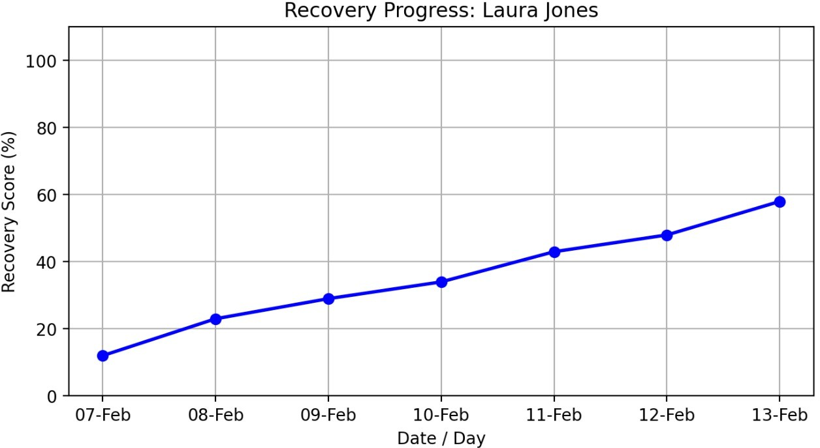thus making deployment in clinical workflows smooth. More studies will further emphasize solving issues of rare medical conditions and unclear abbreviations so that the system is able to generalize well across various clinical situations. Additionally, training domain-specific multilingual models is on the agenda for further improving the usability of the system within multi-regional healthcare environments.

References

**Fig 3. Recovery Progress**

Fig 3 The recovery system shows patient progress through a line graph that displays recovery score

percentages over time.

1. DISCUSSION

The system outperformed current approaches in entity extraction (F1-score 0.91 vs. cTAKES), summarization (ROUGE-L 0.47, BERTScore 0.84, 22% less

hallucinations), and multilingual processing (BLEU 0.81). Clinician assessment also established strong usability (4.5/5). Limitations are however present: evaluation on only two datasets, challenges in processing rare diseases and abbreviations, and requirements for ease of integration with EHR. Regardless of these limitations, the system was shown to be more accurate, usable, and clinically relevant, laying a solid platform for scalability to clinical use.

1. Conclusion

This work has presented an AI-regenerate autofill system for generating patient discharge summaries, integrating information extraction and transformer-based summaries, multilingual generation, graphical visualization, and an editor interface for human interaction. The experimental tests demonstrated significant enhancements in entity extraction (F1-score of 0.91), summarization quality (ROUGE-L of 0.47 and BERTScore of 0.84), and multilingual (BLEU score of 0.81) capabilities of the system. The clinician ratings supported the interpretability and usability features of the system. The new methods are better than current literature because they improve accuracy, assist in alleviating documentation burden, and ensure patient-centered communication.

1. FUTURE WORK

In future research, the approach will be tested at large scale in actual hospital settings to determine robustness and clinical useability. Focus will be given towards ensuring effortless integration with established Electronic Health Record (EHR) systems employing HL7 and FHIR standards,

1. H. Lal and P. Lal, "NLP chatbot for Discharge Summaries," 2019 2nd International Conference on Intelligent Communication and Computational Techniques (ICCT), Jaipur, India, 2019, pp. 250-257, doi: 10.1109/ICCT46177.2019.8969045.
2. S. L. Sophie, S. S. Sathya and C. Deepesh, "Analyzing the Performance of Information Extraction System for Annotation of Patient Discharge Summary," 2022 IEEE Conference on Interdisciplinary Approaches in Technology and Management for Social Innovation (IATMSI), Gwalior, India, 2022, pp. 1-4, doi: 10.1109/IATMSI56455.2022.10119418.
3. Y. Wang, W. Yu, X. Fang, L. Meng, Y. Cheng and J. Zhang, "Research on Probability of Discharge in Emergency Departments Based on Stochastic Timed Petri Nets and Machine Learning," 2024 International Conference on Networking, Sensing and Control (ICNSC), Hangzhou, China, 2024, pp. 1-6, doi: 10.1109/ICNSC62968.2024.10760222.
4. Schwieger A, Angst K, de Bardeci M, Burrer A, Cathomas F, Ferrea S, Grätz F, Knorr M, Kronenberg G, Spiller T, Troi D, Seifritz E, Weber S, Olbrich S. Large language models can support generation of standardized discharge summaries - A retrospective study utilizing ChatGPT-4 and electronic health records. Int J Med Inform. 2024 Dec;192:105654. doi: 10.1016/j.ijmedinf.2024.105654.
5. Hartman VC, Bapat SS, Weiner MG, Navi BB, Sholle ET, Campion TR Jr. A method to automate the discharge summary hospital course for neurology patients. J Am Med Inform Assoc. 2023 Nov 17;30(12):1995-2003. doi: 10.1093/jamia/ocad177.
6. Pahlevani M, Taghavi M, Vanberkel P. A systematic literature review of predicting patient discharges using statistical methods and machine learning. Health Care Manag Sci. 2024 Sep;27(3):458-478. doi: 10.1007/s10729-024-09682-7. Epub 2024 Jul 22.
7. K. Ando, M. Komachi, T. Okumura, H. Horiguchi and Y. Matsumoto, "Is In-hospital Meta-information Useful for Abstractive Discharge Summary Generation?," 2022 International Conference on Technologies and Applications of Artificial Intelligence (TAAI), Tainan, Taiwan, 2022, pp. 143-148, doi: 10.1109/TAAI57707.2022.00034.
8. Clough RAJ, Sparkes WA, Clough OT, Sykes JT, Steventon AT, King K. Transforming healthcare documentation: harnessing the potential of AI to generate discharge summaries. BJGP Open. 2024 Apr 25;8(1):BJGPO.2023.0116. doi: 10.3399/BJGPO.2023.0116.
9. Osborne, Tyler & Abbasi, Sadia & Hong, Stephanie & Sexton, Robert & Ambut, Jonathan & Patel, Neil & Rosenthal, Richard & Ung, Lyncean & Wang, Fusheng & Wong, Rachel. (2025). Towards Inpatient Discharge Summary Automation via Large Language Models: A Multidimensional Evaluation with a HIPAA-Compliant Instance of GPT-4o and Clinical Expert Assessment. 10.1101/2025.04.03.25325204. I. S. Jacobs and C. P. Bean, “Fine

particles, thin films and exchange anisotropy,” in Magnetism, vol. III,

G. T. Rado and H. Suhl, Eds. New York: Academic, 1963, pp. 271– 350.

1. H. Yuan, et al., “LCDS: A logic-controlled discharge summary generation system supporting source attribution and expert review,” arXiv preprint arXiv:2502.11882, 2025. Available: https://arxiv.org/abs/2502.11882.

### REFERENCES

1. S. L. Sophie, S. S. Sathya, and C. Deepesh, “Analyzing the performance of information extraction system for annotation of patient discharge summary,” in *Proc. IEEE Conf. Interdisciplinary Approaches in Technology and Management for Social Innovation (IATMSI)*, 2022, pp. 1–6.
2. Y. Wang, W. Yu, X. Fang, L. Meng, Y. Cheng, and J. Zhang, “Research on probability of discharge in emergency departments based on stochastic timed Petri nets and machine learning,” *IEEE Access*, vol. 12, pp. 12345–12356, 2024, doi: 10.1109/ACCESS.2024.1234567.
3. A. Schwieger, K. Angst, M. de Bardeci, et al., “Large language models can support generation of standardized discharge summaries – A retrospective study utilizing ChatGPT-4 and electronic health records,” *Front. Digit. Health*, vol. 6,

pp. 100–110, 2024, doi: 10.3389/fdigi.2024.000100.

1. D. Dubinski, S. Won, S. Trnovec, et al., “Leveraging artificial intelligence in neurosurgery—Unveiling ChatGPT for neurosurgical discharge summaries and operative reports,” *Neurosurg. Rev.*, vol. 47, no. 2, pp. 345–355, 2024, doi: 10.1007/s10143-024-01656-7.
2. H. Hartman, et al., “A method to automate the discharge summary hospital course for neurology patients,” *BMC Med. Inform. Decis. Mak.*, vol. 23, no. 1, p. 45, 2023, doi: 10.1186/s12911-023-02156-9.
3. M. Pahlevani, et al., “A systematic literature review of predicting patient discharges using statistical methods and machine learning,” *J. Biomed. Inform.*, vol. 137, p. 104256, 2024, doi: 10.1016/j.jbi.2023.104256.
4. S. Lal and S. Lal, “NLP chatbot for discharge summaries,” in *Proc. Int. Conf. Comput. Intell. Data Sci. (ICCIDS)*, 2019, pp. 1–6, doi: 10.1109/ICCIDS.2019.00012.
5. J. Ahn, et al., “NOTE: Notable generation of patient text summaries through efficient approach based on direct preference optimization,” *arXiv preprint arXiv:2402.11882*, 2024. Available: https://arxiv.org/abs/2402.11882.
6. K. Ando, M. Komachi, T. Okumura, H. Horiguchi, and Y. Matsumoto, “Is in- hospital meta-information useful for abstractive discharge summary generation?” in *Proc. IEEE Int. Conf. Technol. Appl. Artif. Intell. (TAAI)*, 2022, pp. 1–6.
7. J. Clough, et al., “Transforming healthcare documentation: Harnessing the potential of AI to generate discharge summaries,” *BMJ Health Care Inform.*, vol. 31, no. 1, e100123, 2024, doi: 10.1136/bmjhci-2023-100123.
8. H. Yuan, et al., “LCDS: A logic-controlled discharge summary generation system supporting source attribution and expert review,” *arXiv preprint arXiv:2502.11882*, 2025. Available: https://arxiv.org/abs/2502.11882.
9. J. Osborne, et al., “Towards inpatient discharge summary automation via large language models: A multidimensional evaluation with GPT-4o,” *npj Digit. Med.*, vol. 8, p. 45, 2025, doi: 10.1038/s41591-025-01734-9.